Trajectories and Outcomes of Informalisation of Employment in India since the early 1980s
1. Introduction
The trajectories of capitalist transformation and their implications on employment and income have been researched over time and space. The important issues of these changes cover a large spectrum and are complex to analyse. This paper seeks to reflect on some of the major challenges and key concerns associated with rural employment under the neo-liberal era in India. It will bring together existing literature and data to understand the employment situation. The employment conditions vary across various regimes, which depend upon the larger structure of the economy. These conditions are connected with nature and particularities inherent in economic development and labour absorption. To compare the changes in employment scenario, this paper, basically, tries to capture the trends almost a decade before and after the economic liberalisation.
Developing countries like India had managed to create a policy space for economic transformation. The period from independence to the late 1980s experienced a public-sector-lead industrialisation, which aimed at smooth economic transformation through state-led regulations. It is well argued that these efforts in many developing countries, such as, East Asian Countries in the 1980s and the 1990s started gaining respectable economic transformation through industrialization (Jomo, 1990; Hsiao & Mei-Chu, 2003; Jha, 2003; Papola, 2007; Chandrashekhar & Ghosh, 2007, Studwell, 2013; Jha, 2016). However, these efforts came to an end when India introduced the neo-liberal reforms in the economy that suggested a decline in the public sector, liberalisation for private sector and decline in state-led investment policies. As a consequence of new policies, despite a high rate of economic growth, there is a clear decline in the growth of employment. Further, a major proportion of the workforce is still engaged in agriculture, however, declining. The services sector is bloated as it has become a kind of ‘parking lot’ for those expelled from agriculture but unable to get absorbed in the formal industrial sector, constituting the overwhelming proportion of the urban informal economy (Jha, 2016). With this understanding, it is important to examine possible reasons for unconventional structural transformation in India, comparing pre-reform and reform period.
The paper has been divided into six sections. The second section explains the employment and the GDP growth in India during pre-reform and reform period. The third section examines the change in the structure of employment and economy during the period of analysis. The fourth section analyses informalisation of the workforce in the reform period in India. The next section draws the attention on how the economic policies and the employment conditions have altered the distribution of income across formal and informal sectors. Final section sums up the main conclusions of this chapter.
- A Snapshot of Employment Growth in India
Workforce participation rates (WPR) since 1977-78 onwards describe fluctuations, and decline on the whole. It was 42.3 percent in 1977-78 which was highest ever until the recent period. During the period 1977-78 to 1993-94, it hovered around 42 percent but never went below 41 percent (refer Figure 1). However, in 1999-00 period, it registered a large decline to the tune of 39.7 percent. This was the first period since the adoption of structural reforms which showed a decline of 2.7 percent compared to its previous period. UPSS further dramatically increased in 2004-05 for which most of the scholars have explained distress as the main reason (Unni & Raveendran, 2007; Abraham, 2009; Kannan & Raveendran, 2009). In the next two subsequent periods, it further declined and reached the level of 38.6 percent in 2011-12. The rural-urban UPSS explains that rural UPSS always remained higher than its urban counterpart. It has been found that while rural UPSS has shown a decline from its initial period, especially since the early 1990s, the urban UPSS has shown a relative increase since 1977-78 with some fluctuations. It explained that where overall employment has gone down, the rural employment declined more sharply.
The reference period for UPSS approach is 365 days, which does not capture the seasonal fluctuations. The estimates of current weekly status (CWS) and current daily status (CDS) explain the intensity of employment. Table 1 describes all the three approaches of WPRs. WPR according to UPSS shows that there are large male and female differentials throughout all the periods.
Figure 1: Workforce Participation Rate in India since 1977-78, Rural-Urban
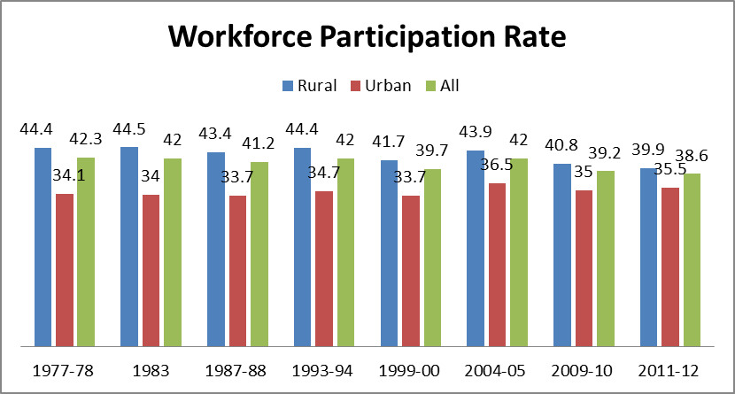
Source: Employment and Unemployment Rounds of NSS (various rounds).
Figure 1 shows that the fluctuations in UPSS are mostly accounted for female UPSS as male UPSS during all the periods did not experience any sudden change, except the period of 1999-00. It has been observed that the rural UPSS is higher than that of its urban counterpart. Further, it has been seen that this trend is especially accounted for female UPSS. The rural-urban gap between female UPSS has been narrowing down in 2004-05 to 2011-12 which is due to decline in rural female UPSS. Various scholars have contested these results and provided various explanations such as an increase in enrolment ratio, increase in domestic duties which have not been captured in labour force, withdrawn from the workforce due to increase in wage rates, etc. However, the majority of them concluded that the missing female labour force has moved to sectors which are “difficult to measure” by NSS surveys. They have moved to low-productivity informal work and subsistence work within the labour market, as a coping strategy (Himanshu et al., 2011; Rangarajan et al., 2011; Hirway, 2012; Kannan & Raveendran, 2012; Abraham, 2013). Further, comparing all the three approaches of WPRs, it is observed that the WPR in UPSS is always higher for all the categories of workers followed by CWS and CDS. This phenomenon explains that while UPSS is an indicator of the overall quantity of employment, the CWS and CDS examine the intensity of work. Both CWS and CDS are the indicators of work availability in a particular time and thus, explain the seasonal fluctuations. However, we are more concerned about the long-term employment scenario rather than the intensities of work at a particular time. Therefore, the preceding discussion will be based on UPSS only. As observed in UPSS, the WPR rate is declining overall; it is essential to find the sources of employment growth and its trend since the 1980s. Therefore, the analysis of employment in various broad sectors needs to be examined.
Table 1: A Comparison of Various Employment Indicators
Year  (NSS Round) | CDS |  |  |  | CWS |  |  |  | UPSS
Year  (NSS Round) | Rural |  | Urban |  | Rural |  | Urban |  | Rural |  | Urban
Year  (NSS Round) | M | F | M | F | M | F | M | F | M | F | M | F
1977-78 (32nd) | 48.8 | 19.4 | 47.2 | 10.9 | 51.9 | 23.2 | 49 | 12.5 | 55.2 | 33.1 | 50.8 | 15.6
1983 (38th) | 48.2 | 19.8 | 47.3 | 10.6 | 51.1 | 22.7 | 49.2 | 11.8 | 54.7 | 34.0 | 51.2 | 15.1
1987-88 (43rd) | 50.1 | 20.7 | 47.7 | 11 | 50.4 | 22.0 | 49.2 | 11.9 | 53.9 | 32.3 | 50.6 | 15.2
1993-94 (50th) | 50.4 | 21.9 | 49.6 | 12 | 53.1 | 26.7 | 51.1 | 13.9 | 55.3 | 32.8 | 52.1 | 15.5
1999-00 (55th) | 47.8 | 20.4 | 49 | 11.1 | 51 | 25.3 | 50.9 | 12.8 | 53.1 | 29.9 | 51.8 | 13.9
2004-05 (61st) | 48.8 | 21.6 | 51.9 | 13.3 | 52.4 | 27.5 | 53.7 | 15.2 | 54.6 | 32.7 | 54.9 | 16.6
2009-10 (66th) | 50.1 | 18.2 | 52.2 | 11.7 | 53.1 | 22.3 | 53.6 | 13 | 54.7 | 26.1 | 54.3 | 13.8
2011-12 (68th) | 50.4 | 16.9 | 52.8 | 12.5 | 52.6 | 20.7 | 53.9 | 13.8 | 54.3 | 24.8 | 54.6 | 14.7
Source: Employment and Unemployment Rounds of NSS (various rounds).
Note: M=Male; F=Female
The overall growth of employment during the first five-years of the analysis was 1.89 percent which accentuated to 2.35 percent in the next period but declined to 1.11 percent during 1994 to 2000 that is just after the introduction of economic reforms (refer Appendix Table A2). It dramatically increased to the tune of 2.79 percent during the period 1999-2000 to 2004-05 but again declined to 0.21 percent during 2004-05 to 2009-10. During 2009-10 to 2011-12, it again showed a little increase (refer Appendix Table A2). The analysis suggests that the high rate of employment growth during 1999-2004 was not justified because a long-term analysis of employment growth trends reveals decline. This growth may be the outcome of an increase in the participation due to income shock and consequent increase in the petty trades (Himanshu et al., 2011; Papola & Sahu, 2012; Bhalla & Kaur, 2013). The overall growth during 1983 to 1993-94 remained relatively higher compared to any other period (i.e. 2.16 percent). In the period of the neo-liberal policies, the employment grew at a rate of 1.32 percent (refer Figure 2).
The analysis shows that the longer period trends explain a secular decline, however, shorter periods show a fluctuation. Among the sub-sectors of the economy, agricultural sector registered the lowest growth particularly after 1993-94 (-0.36 percent) (refer Appendix Table A2). It attained negative growth rate after 2004-05. In the pre-reform period, the growth of employment in agriculture was 1.72 percent (refer Figure 2). During the reform period, 1999-2004 was the only period when the growth remained more than one percent in agriculture. Industrial employment experienced fluctuations especially since 1999-2000. The employment growth prospects of industry showed higher rates during reform period (4.12 percent) than in the pre-reform period (i.e. 2.66 percent). It can be inferred that within Industry, this is construction sector which is registering high growth rates.
As evident from figure 2, construction sector experienced a high growth in the recent period. The employment in this sector is growing at a higher rate (7.09 percent) from 1983 to 2011 (refer Appendix Table A2). However, the employment generation in this sector is majorly casual. Most of the workers employed in this sector are denied social security and labour regulations. Majority of the workers in this sector belong to lower caste and poor strata of the society and work in low-skilled construction works. Most of the contracts remain oral and are decided at the workplace (Srivastava & Jha, 2016). Female labourers work at the bottom of the recognised skill hierarchy and receive lower wages than their male counterparts. Labour contracts are independently determined and the remuneration is either fixed for an entire working day or over time if given, is lower than the legal amount. Most workers receive wages which are below the legal minimum, more so in the case of unskilled work (Gupta, 2003; Korinek & Loebach, 2016; Srivastava & Jha, 2016).
The manufacturing sector employment growth remained low since 1983 except for the period 1999-2004 (refer Appendix Table A2). The growth in the 2000s shows mixed results, it registered a negative growth rate during 2004-05 to 2009-10, while in the next two years it registered a growth of seven percent. In the tertiary sector, it has been observed that the employment growth always remained less than 4 percent, however, in the pre-reform period, the growth rate was higher (3.51 percent) than the growth (2.93 percent) in the reform period (refer Figure 2). It shows that the industrial sector has generated more employment opportunities than the tertiary or the agricultural sector (refer Appendix Table A2).
Figure 3: Employment and Output Growth (CAGR) Across Various Sectors in India during Pre-Reform and Reform Period
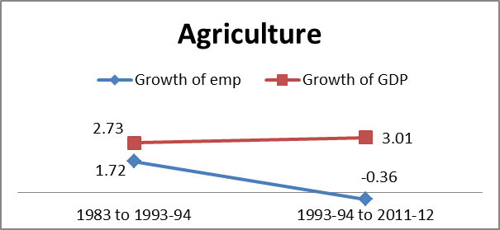 | 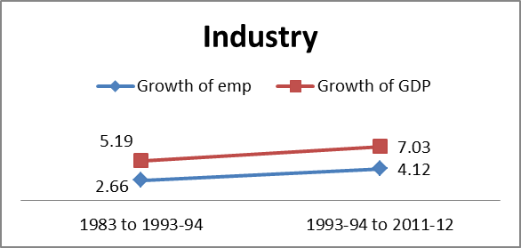
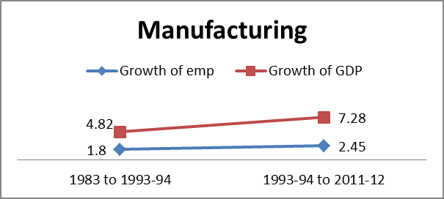 | 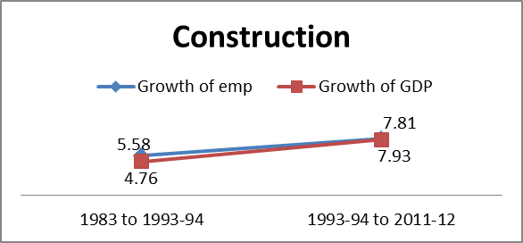
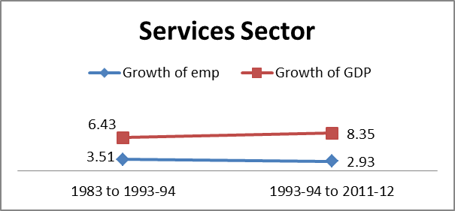 | 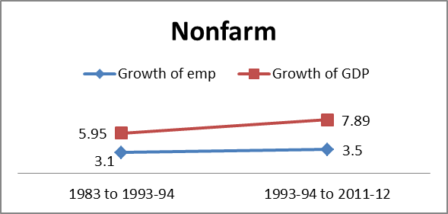

Figure 2(continued): Employment and Output Growth (CAGR) Across Various Sectors in India during Pre-and Reform Period
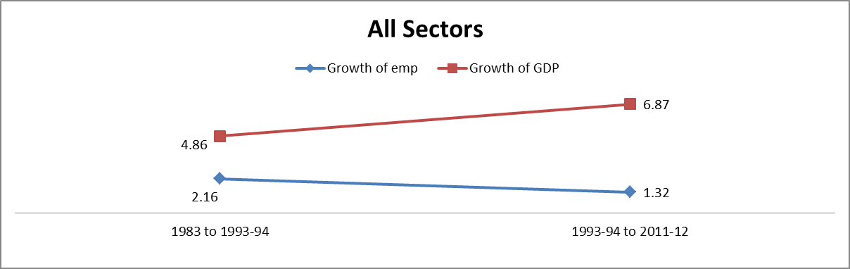
Source: Computed from Employment and Unemployment Surveys of NSS and National Accounts Statistics, CSO, (various years)
Figure 3: Employment Intensity of Key Sectors in India during Pre-Reform and Reform Period
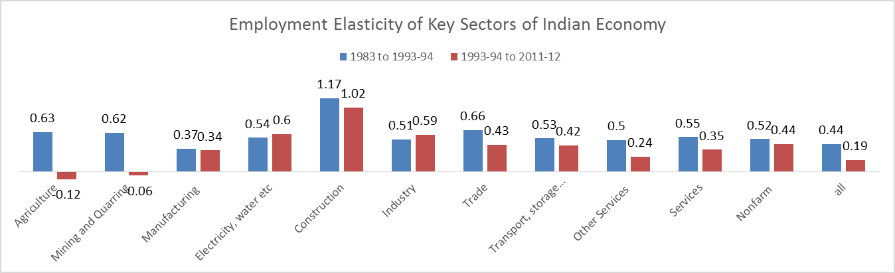
Source: Computed from Employment and Unemployment Surveys of NSS and National Accounts Statistics, CSO, (various years)
One has to look beyond the employment growth and examine what has been the output growth scenario in various sub-sectors of the economy to assess the quality and direction of employment growth. As far as the GDP growth is concerned, it remained at 4.8 percent during the pre-reform period (i.e. 1983 to 1993-94) but increased to 6.8 percent during the reform period (i.e. 1993 to 2011-12) (refer Figure 2). Further, the sub-sectors of the economy suggest that all the three sectors grew at a faster pace in the reform period than in the pre-reform period. In both the periods, agricultural output grew at a slower pace than industrial and tertiary sector. The tertiary sector grew at a very high rate (8.3 percent) in the reform period. The industry grew at more than 7 percent in industrial sector which was growing at only 5.1 percent (refer Appendix Table A2). Among the sub-sectors of the economy, construction (7.8 percent), trade (8.4 percent) and transport (10.5 percent) are the sectors which grew at a higher rate of growth in the reform period. On the whole, it is clear that in the reform period, tertiary sector gained a faster growth, followed by industry and agriculture. The comparative analysis of the growth of employment and output across various sectors describes that in both the periods, the employment growth rates has remained lower than the growth rates of output across sectors, however; this gap has widened further in the reform period (refer Figure 2). In other words, where GDP growth has increased in the reform period, the employment trends across all the sectors do not reflect that positive change. Except for the construction sector, the growth of employment has remained lower than the growth of output in all the sectors in reform period.
The conventional theories suggest that the growth of output facilitates the growth of employment. To check this relationship, it is important to analyse the employment elasticity of growth (refer Figure 3). Employment elasticity of all the sectors remained high (0.48) during 1983 to 1987-88 which declined (0.43) marginally in the next period (refer Appendix Table A4). Just after the introduction of reforms (1993-1999), it declined to just 0.17, but increased drastically during 1999-00 to 2004-05 to the tune of 0.50. In the first decade of 21st century, it plummeted to 0.03 in the period 2004-2009 (Table A4). This trend continued even in the last period. It has been clear from the overall trends of employment elasticity that during the 1980s the employment generation was better where employment elasticity remained 0.44 in 1983 to 1993-94 whereas it remained only 0.19 during 1993-94 to 2011-12. Employment elasticity experienced fluctuations in the agricultural sector, however in recent periods, it has shown the negative trends, indicates that there is a decline in employment in absolute terms in this sector. The industrial sector registered a very high rate of employment elasticity (0.99) during 1983-87 period followed by low levels till 1999-2000. Further, the period after 1999-2000 experienced fluctuations (Table A4). However, the industrial sector has registered relatively high employment elasticity 0.39 and 1.09 for the periods 2004-2009 and 2009-2011 respectively.
Within the industry, it has remained higher for construction followed by manufacturing sectors. In the pre-reform period, it was 1.17 and 0.37 for construction and manufacturing sectors respectively as compared to 1.02 and 0.34 for these sectors during the reform period. For the tertiary sector, trade and transport sub-sectors are registering relatively higher employment elasticities than any other sectors; for trade (0.43) and transport (0.42), it remains lower in reform period than that of the pre-reform period (0.66 for construction and 0.53 for transport). On the whole, it has been found that industrial sector has experienced relatively higher rates of employment elasticity than agricultural and services sector.
The discussion summarises following points; first, the secondary sector has greater prospects of employment generation as the employment elasticity gives higher rates than agriculture and services. Secondly, the employment absorption in agriculture has remained stagnant in the recent period, particularly after the reform period. Thirdly, the service sector has low employment opportunities in the reform period. Fourthly, the period 1999-2000 to 2004-05 provide very complex results as it showed higher employment elasticity for all the sectors and also higher UPSS, while the growth of output during the same period remained low as compared to the subsequent periods. It indicates that this employment generation led to distress induced phenomenon. Lastly, the tertiary sector output growth registered high rates in reform period, while employment growth remained lower in this period than in the pre-reform period.
The agricultural employment in rural India declined after 2004-05 for both male and female workers (refer Appendix Table A5). The employment rates during 1999-2004 remained at the highest level than any other period, in general, and for females (2.6 percent), in particular. This period has also experienced feminization of agriculture at a high rate (Mazumdar & Neetha, 2011). Industrial sector registered a high rate of growth both for male (6.5) and female (10.0) workers during 1983 to 1987-88 after that it has declined till 1999-2000. It revived in the period 1999-00 to 2004-05 for both male and female, however, in the subsequent period, the employment grew at a moderate rate only for rural males. The possible reason is feminisation of agriculture as more female workers joined agriculture as compared to the male workers.
Figure 4: Employment Growth (CAGR) Across Various Sectors in India during Pre-Reform and Reform Period, Rural-Urban and Male-Female, in percent
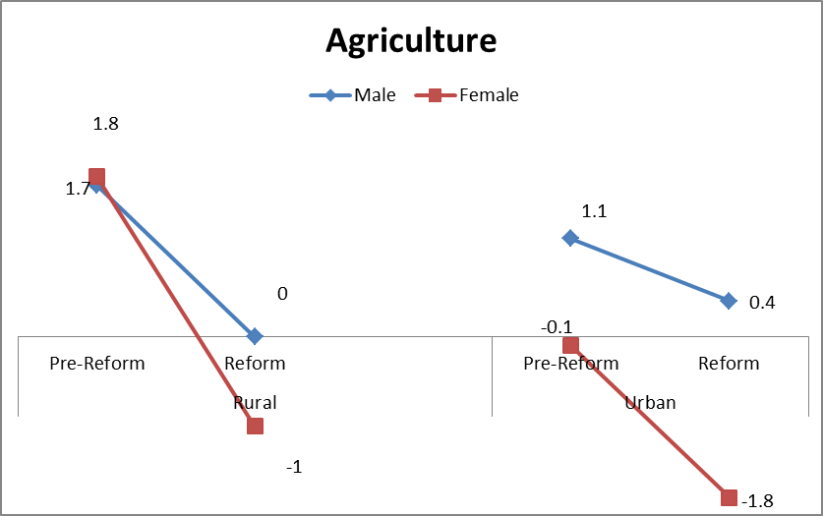
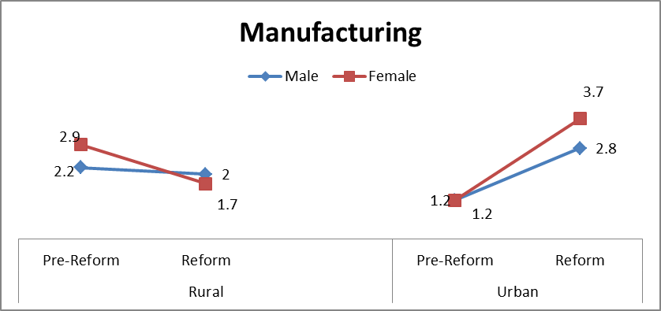
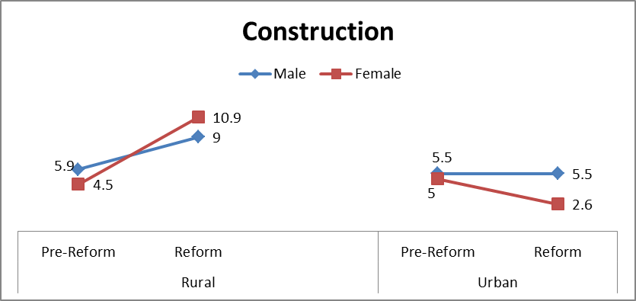
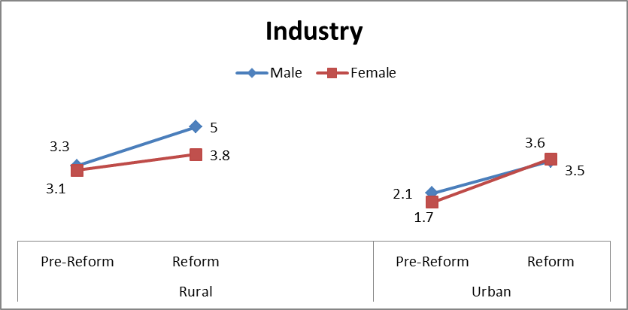
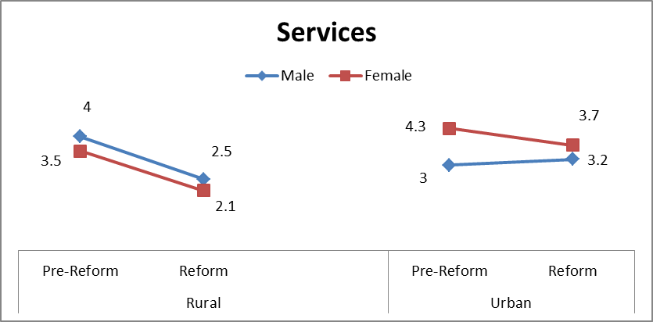
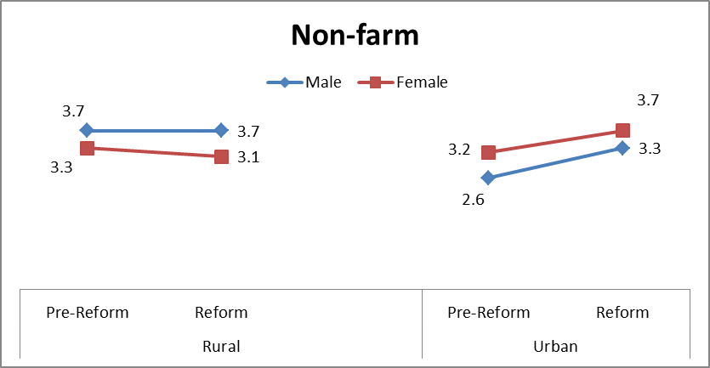
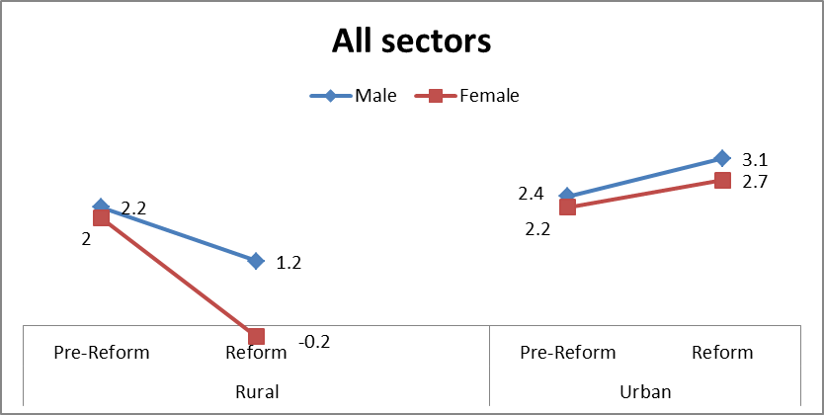
Source: Produced from Employment and Unemployment Survey, NSS (various years)
Within the industry, the growth rate of the manufacturing sector in rural India remains poor bearing some periods of exception. It remained low both for male (2.0 percent) and female (1.7 percent) in the reform period as compared to the pre-reform period (refer Appendix Table A5). However, the construction sector has remained the main driver of the secondary sector employment growth. This sector gained higher employment rates during 1993-2011 (9 percent for male and 10.9 percent for female workers) as compared to 1983-1993 (where male and female employment grew at 5.9 percent and 4.5 percent respectively). The services sector has registered moderate employment growth during the pre-reform period both for male (4.0 percent) as well as female (3.5 percent) workers but registered a decline in the reform period (2.5 and 2.1 percent for male and female workers respectively (refer Figure 4). Trade and transport remained the main source of employment in the tertiary sector for males whereas for females, only trade emerged as the main source of tertiary sector employment growth. The overall employment growth in rural India has remained very low. However, it remained at 2.2 percent and 2.0 percent for male and female workers respectively in the pre-reform period which is higher than 1.2 and -0.2 percent in reform period (refer Figure 4).
In urban employment scenario, it has been observed that the number of workers in the agriculture sector has declined since 1983 but increased in some periods (refer Appendix Table A6). The interesting trend can be seen for agricultural employment for female workers during 1999-2004 in urban India, which grew at 7 percent and for male workers at 2.3 percent. This trend again confirms that due to distressed economic conditions, workers in general and women workers, in particular, opted for agricultural activities for their livelihood. Further, industrial sector attained low to moderate employment growth both for male and female workers till 1999-2000 (refer Appendix Table A6). It registered high growth rate for both male and female workers in the period of 1999-2005. In the next period, it again declined to 2.5 percent for male workers and -0.2 percent for female workers. Taking into consideration the two aggregate periods, it gained higher employment growth both for male (3.5 percent) and female (3.6 percent) workers in the reform period than the previous period where male and female employment grew at 2.1 and 1.7 percent respectively (refer Appendix Table A6).
Manufacturing sector registered comparatively a higher growth rate in the reform period (i.e. 2.8 percent and 3.7 percent respectively for male and female workers as compare to 1.2 for both in the pre-reform period), but the pace remained poor on the whole. Construction sector registered a higher employment growth for males (5.5 percent) than female (2.6 percent) workers in the reform period (refer Figure 4). Employment growth for female construction workers has declined from 5 percent in pre-reform to 2.6 percent in reform period. Services sector experienced a lower employment growth for urban female workers (4.3 during 1983-1993 and 3.7 during 1993-2011) in the pre-reform period, while male workers registered a slight increase in the reform period (from 3 percent to 3.2 percent). Within the tertiary sector, trade and transport sectors remained the main source of employment growth which have also registered higher employment growth rates during the reform period both for male and female workers.
The employment growth in India remained low since 1983, and it further declined in the reform period. The agricultural employment growth declined drastically since the last two decades except for 1999-2000. There has been a decline in absolute numbers of agricultural workers. The period of 1999-2004 provides a perplexing picture where agricultural workers increased not only in the rural region but urban India as well. The growth of female agricultural workers in this period remained higher than that of their male counterparts. The economic conditions of this period suggest that this growth in employment is distress-induced. The secondary sector employment growth in India remained moderate during the reform period. The main reason for this trend is the construction sector boom, whereas, the growth of manufacturing sector remained poor across region and gender. The employment intensity of the secondary sector indicates higher employment prospects in the secondary sector. The higher output growth of the tertiary sector has not been concomitant in the tertiary sector employment in the recent periods. This sector experienced a slightly higher employment growth in the pre-reform period.
The overall employment growth rates are higher in urban India than that of rural India both for female and male workers in the reform period. It implies that the employment prospects are more in urban India in the reform period. Overall economic growth in the reform period has not been employment intensive. Employment growth has remained low in the reform period as compared to the growth in the pre-reform period. The employment elasticity of growth that measures the employment content of growth has declined on the whole in the reform period.
3.3 Changing Structure of Employment
It has been observed that the share of employment had fallen in the agricultural sector which shifted to the non-agricultural sector (refer Figure 5). The proportion of rural male and female workers engaged in the agricultural sector declined 18.1 and 12.6 percentage points respectively between 1983 to 2011-12 period whereas, the share of RNF male and female workers increased 18.3 and 13 percentage points in the same period (refer Figure 5). As far as urban India is concerned, during 1983 to 2011-12, the decline of agricultural male and female workers is registered for 4.7 and 20.1 percentage points respectively while the increase for the urban non-farm sector is 20.9 and 5.3 percentage points. After agriculture, the change in employment share from 1983 to 2011-12 across sub-sectors is found to be higher for the industrial sector in rural India (11.9 for male and 9.4 for female workers) and services in urban India (4.1 and 17.5 for male and female workers respectively).
The discussed results were the long-term trends of change in employment structure during the pre-reform and the reform period as far as the short-term trends are concerned, the share of male employed in agriculture declined.. This change is particularly observed from 1993-94 (refer Appendix Table A7). However, the change has been very slow among female labour. It started declining recently since 2004-05 (it was 83 percent in 2004-05 which declined to 59 percent in 2011-12). For rural males, the share of secondary and tertiary sector employment for 2011-12 is 22 percent and 19 percent respectively. These sectors registered approximately 13 percent (secondary) and 8 percent (tertiary) increase during 1977-78 to 2011-12. Among rural females, the tertiary sector accounts for a small proportion (approximately 8 percent) whereas, the secondary sector accounts for 17 percent in the latest period. It has been found that the tertiary sector hardly gained in the rural region especially for female employment. In rural India after agriculture manufacturing (8.1 percent), construction (13 percent), trade (8 percent) and services (6.4 percent) are the dominant sectors both for male as well as female workers.
The notable changes are occurred in the sectors are construction sector followed by transportation and storage. The construction sector’s share of employment starts increasing from 1999-00 (refer Appendix Table A7). For rural males, employment shares of transportation and storage sectors employment share show continuous though small rise since 1993-94. Services sector shows an increasing trend from 1977-78 till 1993-94 but afterwards it registered continuous decline till 2009-10 for rural male workers. For rural females, the services sector shows a consistent increase. The manufacturing sector in rural India registered abrupt trends across all years of analysis. During 1977-78, the share of manufacturing sector increased till 1987-88 however, during the subsequent period, it experienced a decline. After a rise in 1993-94, it registered a minuscule increase till 2009-10. In sum, it can be said that after 1993-94, in rural employment, services sector has gone down while manufacturing sector registered almost a stagnant growth. The only sector that experienced a high share in the recent periods is the construction sector. The agriculture sector is still playing a dominant role (refer Appendix Table A8).
Figure 5: Percentage Change in Employment Share of Each Sector, 1983 to 2011-12
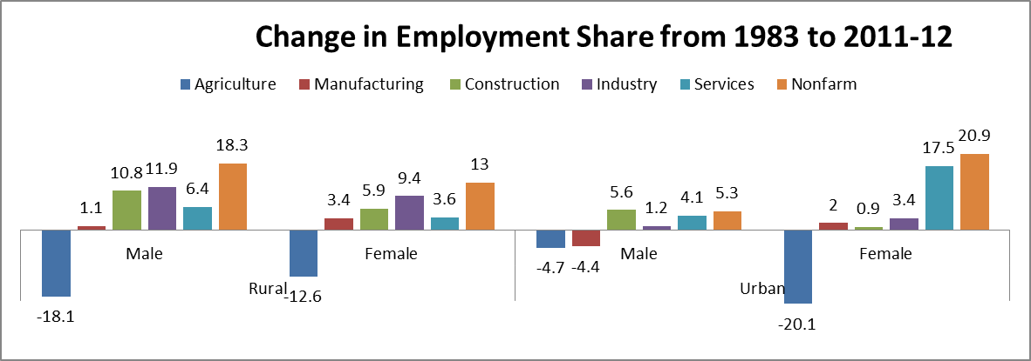
Source: Produced from Employment and Unemployment Survey, NSS (1983, 2011-12).

Figure 6: Percentage Change in GDP Share of Each Sector, 1983 to 2011-12
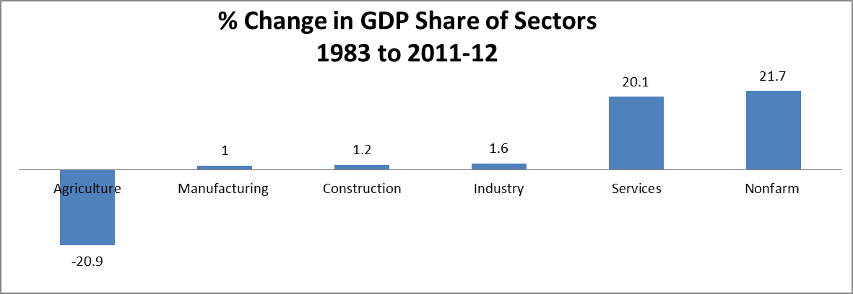
Source: Produced from Employment and Unemployment Survey, NSS (1983, 2011-12).

Urban employment evinces a contrary view (refer Appendix Table A8). For the obvious reasons, agriculture employment does not contribute a major share. The secondary sector remained stagnant in terms of employment share. Its share was 34 percent for male and 32 percent for female workers, which increased to 35 percent and 34 percent respectively in the latest period. In the tertiary sector, there are some notable changes during 1977-78 to 2011-12.
The decline in the share of employment of agriculture has been absorbed in the tertiary sector. It increased 20 percentage points for urban female workers from 1977-78 to the latest period, however, among males the share was already very high in the initial period and finally reached to more than 59 percent in the most recent period. As far as the manufacturing sector is concerned, the share of employment has never touched 30 percent both for male and female workers. It has declined over the period. While the share of the construction sector has shown a gradual increase over the years. In the tertiary sector, the share of trade-related services has gone up in the reform period both for male and female workers. The share of other services has also increased in this period. It is evident from the distribution that in the reform period, the significance of the tertiary sector has grown, particularly, the share of female workers in the sector has increased.
The employment shift from 1977-78 to 2011-12 suggests that while in rural India, the shift of employment share accounted from agriculture to secondary sector (though small), in the urban region it accounted from agriculture to tertiary sector almost neglecting the secondary sector (refer Figure 5). It has been found that female workers are still dominating in the agricultural sector both in rural as well as in urban regions. It is evident from the employment trends since the 1980s that the employment has not shown a much structural transformation in rural India in particular. In Urban India, whatever shift has happened is on the account of increase in the tertiary sector.
The change in the structure of GDP is quite evident during 1983 to 2011-12 (refer Table A6). The change is highest for the agricultural sector (20.9 percent decline) followed by services sector (20.1 percent increase). It seems that the decline in agricultural GDP is accounted for an increase in the share of services sector whereas the shares of manufacturing, construction and industrial sector GDP has grown microscopic (refer Table A6). As far as agricultural share in GDP is concerned, it has declined from 35 percent to 14.1 percent over the period of 1983 to 2011-12 however; the decline is much sharper since 1993 (refer Table A9). It declined by more than 14 percentage points since the introduction of the economic reforms.
It has been observed that the structural change is visible in terms of distribution of GDP. However, the path of this shift is unconventional, in the sense that it barely touched the secondary sector which has employment potential. There is not much change in the pattern of employment since the reform period. The share of agricultural GDP has declined drastically, but its share in employment has not reduced much; therefore there is still a dependency on agricultural employment. This unparallel relation between employment and GDP distribution has implications for the personal and functional distribution of income (Gill, 2012). The shift in the composition of aggregate income results in changes in the functional distribution of income.
Figure 7: Percentage Distribution of Type of Employment in India
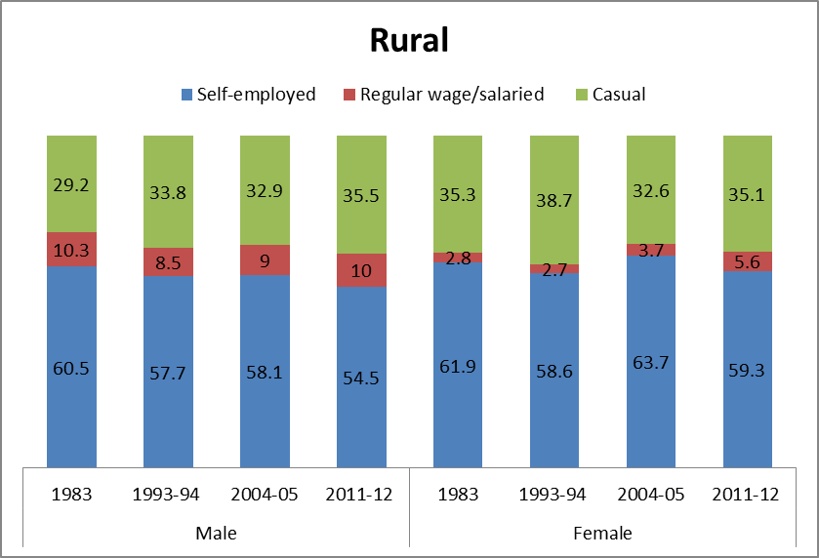
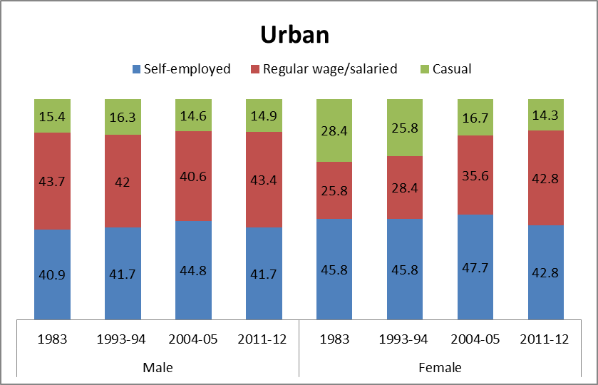
Source: Produced from Employment and Unemployment Survey, NSS (various years)
It has been already observed in the previous section that the employment elasticity of services sector is low and agriculture has reached a stage where the actual number of workers has been declining. In such a situation, the possibility of poor employment increased (Sundaram & Tendulkar, 2002; Jha, 2003; 2010; Abraham, 2009; 2013; Srivastava & Jha, 2016). The manufacturing sector can provide greater opportunities for mass production which can lead to the generation of employment, however, due to the stagnant manufacturing sector this possibility cannot be harnessed. Finally, one can observe the larger share of self-employment where a large number of workers are doing petty trades. The casualisation in the recent decades has increased which is the bio-product of non-conventional structural change in India (Jha, 2006; Papola & Sahu, 2012; Binswanger‐Mkhize, 2012).
The share of self-employed (own-account) workers remained very high across the regions and the gender (Figure 7). It is higher in rural India than in urban India. In the recent decades, the share of self-employed workers has been declining since 2004-05 whereas, the proportion of casual wage labours is on the rise in rural India. This trend is particularly visible since the introduction of the economic reforms. The casualisation in rural India is as high as more than 35 percent in 2010-11 both for male and female workers. The share of regular employment has always remained less than 11 percent of male workers while for female workers, it never crossed 5.6 percent (refer Figure 7). In urban India, the share of self-employed workers also remained high but was lower than that of rural India. The share of regular wage employment remained higher in urban India both for male and female workers. This share is increasing for female workers since 1999-2000. It can be inferred that employment prospects are slightly better in urban India since the level of casualisation has declined after 1999-2000 (refer Appendix Table A10). On the other hand, the employment aspects are very low in rural India since the share of self-employment is very high which indicates that lack of employment opportunities led workers to engage in petty trades (Patnaik, 2007a; Rani & Uni, 2009; Srivastava & Srivastava, 2010; Moyo et al., 2013).
It is well argued that a high proportion of wage and salaried workers in a country can be indicative of ‘advanced’ capitalist development, i.e., a metropolitan country. On the other hand, substantial share of own-account workers (self-employed without hired employees) and large shares of contributing family workers are typically associated with a small ‘formal sector’ and a large agriculture sector along with a variety of informal livelihood options outside agriculture, which are common to peripheries in general (Patnaik, 2007b; Abraham, 2009; Mazumdar & Neetha, 2011). Self-employed are often referred as ‘petty producers’ where a majority of the workers perform as street vendors, poor artisans, marginal and small farmers, home-based workers, etc. (Raveendran et al., 2013). Only a small upper crust among them belongs to the higher-income segment since they belong to high-skilled workers such as doctors, lawyers, etc. Therefore, the employment aspects are indigent when the share of self-employment is higher in a developing country. The next section moves to the trends of informalisation under reform period.
3.4 Trends of Informalisation of Labour
As we have examined that the share of employment in services is bloated, especially in the reform period, the informal sector as most of the peripheral economies experienced, becomes a kind of ‘parking lot’ for those expelled from agriculture (Jha & Thakur, 2012). It is evident from Figure 3.8 that the share of informal workers in the informal sector remained very high in all periods and is increasing over the years. The share of informal workers in the formal sector is also increasing since 1999-00 (refer Figure 8).

Figure 8: Share of Informal Workers in Formal and Informal Sector since 1999-00
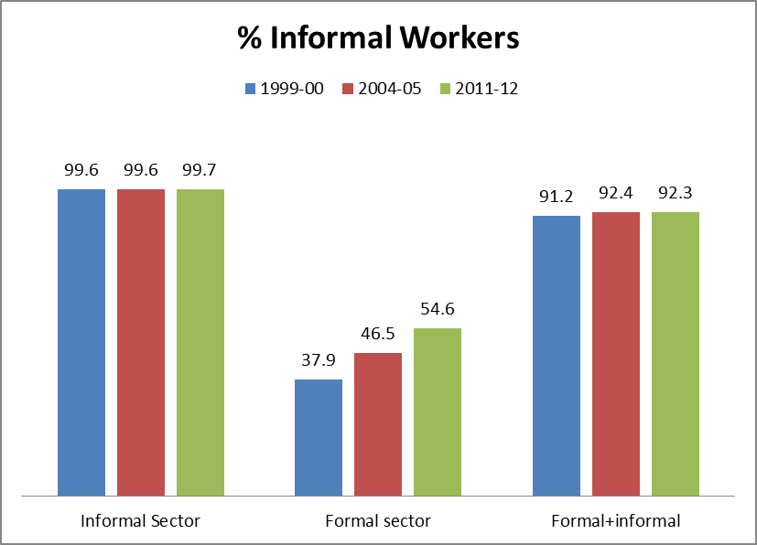
Source: 1. Computed from Unit-level Data on Employment and Unemployment Survey, NSS (2011-12)
2. Figure for 55th and 61st round are adopted from the Report on Conditions of Work and Promotion of Livelihoods in the Unorganised Sector, 2007.
This share has been on the rise; it was 37.8 percent during 1999-2000 which increased to 54.4 percent in 2011-12. Further, the process of informalisation can be viewed from the low share of formal workers within the formal sector; it was 62.2 percent in the year 1999-2000 and declined to 53.4 percent and 47.6 percent in the year 2004-05 and 2009-10 respectively. Finally, it reached the level of 45.5 percent in 2011-12. Therefore, it can be said that the decline of share in this category has been absorbed in the informal jobs either in the formal sector or the informal sector. To confirm the above-stated argument, the proportion of informal workers working in formal sector can be examined. The share has been increasing from 37.8 percent in 1999-2000 to 54.4 percent in 2011-12. It has been on a constant rise since 1999-2000. Both formal and informal sectors constitute 91.2 percent of the informal workforce in 1999-2000 which increased to 92.2 percent in the latest period (refer Appendix Table A11). Formal workers both in formal and informal sectors contributed only 8.8 percent in 1999-2000 which further dipped to 7.7 percent in 2011-12. Informalisation of workers in the formal sectors is an indicative of inter-linkages of formal and informal sectors through labour. Formal sector having larger production capacity and better technical know-how requires lesser labour force. Further, most of their production chains belong to informal labour through sub-contracting and other arrangements that involve decisive policies to neutralise the effects of labour–laws (Breman, 1996; Mamgain & Awasthi, 2001; Chen, 2005; Harris-White & Sinha, 2007; Deshingkar, 2009; Harriss-White & Gooptu, 2009).
Also, the distribution of informal workers across broad industrial category suggests that share of informal workers is the highest in the agricultural sector and has been increasing since 1999-2000 (Figure 9). Secondary sector has also experienced a rise; it increased from 85.5 percent in 1999-2000 to 91.2 percent in 2011-12. The services sector has registered the lowest percentage of informal workers. However, the percentage of informal workers is increasing in this sector from 1999-2000 but relatively at a slower pace. The other sub-sectors of the economy which register relatively low share of informal workers are utility sectors (electricity, water, gas, etc.), other services (includes public administration, defence, etc.) and mining and quarrying sectors. The sectors such as construction, trade and manufacturing are registering a higher rate of informalisation in the economy (refer Appendix Table A12). These are also the sectors, where the majority of the population seeks employment or they are more employment oriented sectors (as seen in the previous section).

Figure 9: Share of Informal Workers across Major Sectors since 1999-2000
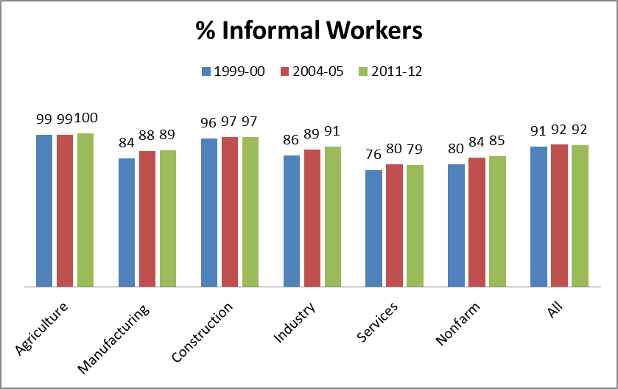
Source: 1. Computed from Unit-level Data on Employment and Unemployment Survey, NSS (2011-12)
2. The figure for 55th and 61st round are adopted from the Report on Conditions of Work and Promotion of Livelihoods in the Unorganised Sector, 2007.
It can be seen from Figure 10 that Kerala was the only state having much lesser (80 percent) extent of informal workers in 1999-2000. However, over the years, the share has been increasing and reached at 90.6 percent in 2011-12 (for more details refer Appendix Table A13). The other states which had less than 90 percent share of informal workers in 1999-2000 were Assam, Haryana, Jammu and Kashmir and Tamil Nadu. However, over the years, these shares reached to the level of over 90 percent.

Figure 10: State-wise Share of Informal Workers since 1999-2000
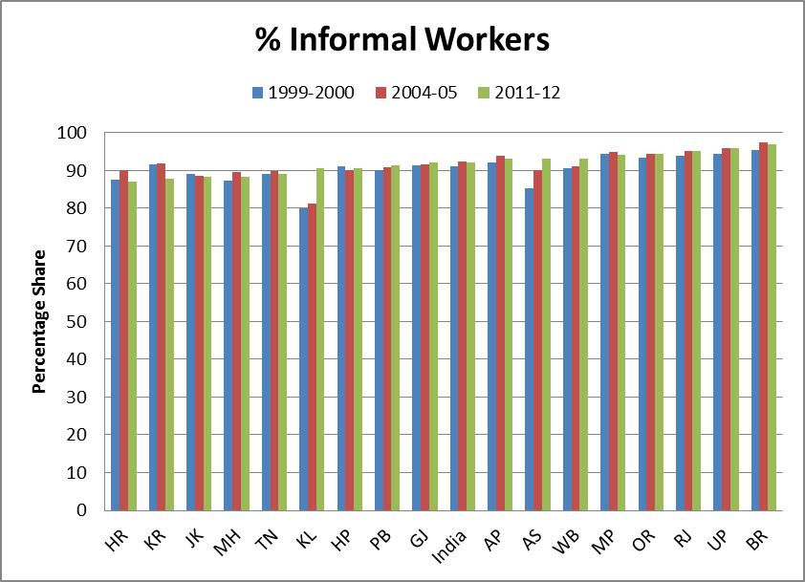
Source: Produced from Appendix Table A13
Note: HP-Himachal Pradesh, KL-Kerala, HR-Haryana, TN-Tamil Nadu, AS-Assam, PB-Punjab, MH-Maharashtra, KR-Karnataka, GJ-Gujarat, OR-Orissa, WB-West Bengal, MP-Madhya Pradesh, BR-Bihar, AP-Andhra Pradesh, RJ-Rajasthan, UP-Uttar Pradesh
The states with a higher share of informal workers (having more than 95 percent) are Bihar, Rajasthan and Uttar Pradesh in 2011-12. The states that experienced a decline or remained at the same level are Haryana, Punjab, Himachal Pradesh, Jammu and Kashmir, Karnataka and Tamil Nadu. It can be said that the economically advanced and high growing states are relatively successful in lowering the shares of informal workers, whereas poor states experienced further worsening of the situation. The states with low economic development do not facilitate its population a reasonable share of jobs in the formal sector. The small self-employed enterprises become the choice of under-employed workers. Rest of the workers join precarious jobs that are available on very low wage rates in the urban region. Thus, the situation of the low level of development creates a huge informal workforce.

Figure 11: Share of Informal Workers by State and Region, 2011-12
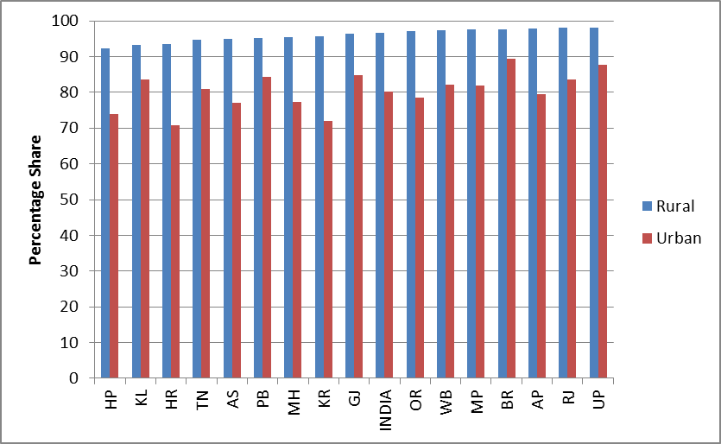
Source: Produced from Appendix Table A14
Note: HP-Himachal Pradesh, KL-Kerala, HR-Haryana, TN-Tamil Nadu, AS-Assam, PB-Punjab, MH-Maharashtra, KR-Karnataka, GJ-Gujarat, OR-Orissa, WB-West Bengal, MP-Madhya Pradesh, BR-Bihar, AP-Andhra Pradesh, RJ-Rajasthan, UP-Uttar Pradesh
Further, if we look at the trends of rural and urban India, the share of informal workers depicts wide disparity (refer Appendix Table A14). In 2011-12, it has been observed that the share of informal workers in rural India is much higher (96.6 percent) than that of urban India (more than 80 percent). Across states, it has been observed that Uttar Pradesh (approximately 98 percent) and Rajasthan (almost 98 percent) have the highest share of rural informal workers whereas, Bihar has the highest share of urban informal workers. In urban India, Haryana, Himachal Pradesh and Karnataka are the states having a relatively lower share of informal workers. It is observed that the informalisation is very high in rural India across all the states. Lack of salaried jobs and seasonal agricultural work make rural labour market highly informal. A vast majority of labour engage in agricultural labour and petty –trades.
Table 2 provides the state-wise distribution of informal workers across various sectors. To simplify the analysis, the extent of informal employment has been divided into four parts according to the percentage of informal employment (less than 60 percent, 80- 60 percent, 90- 80 percent and more than 90 percent). It suggests that in the case of agriculture and allied activities, all the states lie in the highest range of informal employment share (more than 90 percent). The manufacturing sector is one of the significant sources of employment; where the share is found to be more than 60 percent for all the states. However, it accounts the highest share (more than 90 percent) among the poorer states such as RJ, UP, BR, and OD. It also remained the highest for the states of WB, AP, and KL. The states with a relatively lower share (80-90 percent) of informal workers are HR and MH which are also amongst the key industrialised states of India.
Table 2: State-wise Extent of Informal Workers across Sectors, 2011-12
Sector | > 90 percent | 90%-80% | 80%-60% | < 60%
Agriculture | HP, PB, HR, RJ, UP, BR, AS, WB, OD,  MP, GJ, MH, AP, KR, KL, TN | - | - | -
Manufacturing | RJ, UP, BR, WB, OD, AP, KL | HP, PB, AS, MP, GJ, TN | HR, MH | -
Construction | HP, PB, HR, RJ, UP, BR, AS, WB, OD,  MP, GJ, MH, AP, KR, KL, TN | - | - | -
Trade | HP, PB, HR, RJ, UP, BR, AS, WB, OD,  MP, GJ, MH, AP, KR, KL, TN | - | - | -
Transportation etc. | PB, UP, BR, AS, MP, KL | HP, HR, RJ, WB, OD, GJ, AP, KR | MH, TN | -
Other services | HP, PB, HR, RJ, UP, BR, AS, WB, OD,  MP, GJ, MH, AP, KR, KL, TN | - | - | -
All | HP, PB, RJ, UP, BR, AS, WB,  OD, MP, GJ, AP, KL | HR, MH, KR,TN | - | -
Source: Computed from Unit-level Data, Employment and Unemployment Survey, NSS (2011-12)
Note: HP-Himachal Pradesh, KL-Kerala, HR-Haryana, TN-Tamil Nadu, AS-Assam, PB-Punjab, MH-Maharashtra, KR-Karnataka, GJ-Gujarat, OD-Odisha, WB-West Bengal, MP-Madhya Pradesh, BR-Bihar, AP-Andhra Pradesh, RJ-Rajasthan, UP-Uttar Pradesh
Construction, one the significant source of employment presently, involves the highest rate of informal workers after agriculture in 2011-12 (Table 2). The extent of informal employment for all the states is more than 90 percent in this sector. This indicates grave consequences in terms of livelihoods, the standard of livings, etc. of the masses. Trade is also among one of the most important employment sources. All the states are having more than 90 percent of workers engaged in informal employment in this sector. The share of informal workers in transportation and storage sector is spread across first three ranges of percentage divisions. MH and TN have a relatively lower share of informal workers in this sector which is hovering around 60-80 percent. The sectors such as construction and trade which are providing more employment are more informalised across all the states. Further, the rural sector is more informalised than the urban sector. In such a scenario, one can imagine the kind of development is taking place under the neo-liberal regime in India.
3.5 Distribution of Income under the Neo-liberal Era
To understand what have been the reasons and the implications of such an economic development in India, a further look at the various components of GDP is necessary during the reform period. The mismatch of sectoral employment share and output share is the outcome of the policy of liberalisation, privatisation of public enterprises and the promotion of collaboration of private capital with global capital (Chandrashekhar & Ghosh, 2007; Gill, 2012).
It has been found in the previous section that the share of informal sector has increased in terms of employment share, however, its share in income is declining in the reform period. The proportion of informal sector was more than 63 percent in 1993-94 which has fallen to 55 percent in 2009-10 (refer Figure 12). The GDP share of private formal sector increased significantly during the reform period. It rose from 13.1 percent in 1993-94 to 24.9 percent in 2009-10. On the other hand, Public sector registered a decline from 23.7 to 20.1 percent during the same period. These trends are the outcome of reforms that facilitated liberalisation for the corporate sector and the privatisation of public sector enterprises. Underlying the introduction of the neo-liberal policies, the strength and power of corporate sector have increased, and there is a significant influence of private sector in a policy-making circle due to which the debates around labour market flexibility and free market access have come up (Bhaduri, 2009; Gill, 2012).
Figure 12: Sector-Wise Percentage Distribution of GDP
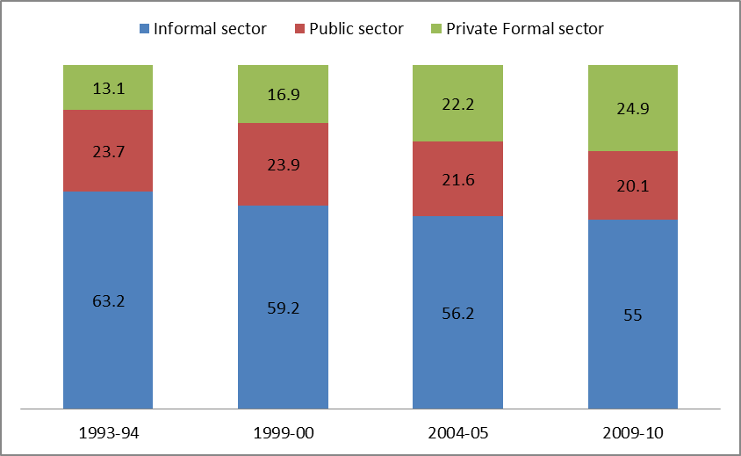
Source: Reproduced from Appendix Table A15
The increase in bargaining power of corporates and declining social security to the workers on the name of labour market flexibility, the gap between the shares of corporate surplus and wage-rate has become significantly high in this period. To examine these trends, we are taking Compensation of Employees (CE) as wage rates and Operating Surplus (OS) as an indicator of profit to the corporate in the formal sector. Whereas, in the informal sector, Mixed Income (MI) and Compensation of Employees are taken as profit and wages respectively.
It can be seen from Figure 3.13 that gap between CE and OS is the lowest for the public sector. During the years, 2000 to 2002, the CE remained higher than OS. The long-term trend suggests that the gap between CE and OS of the Public sector is declining. However, the private organised sector presents a different picture. The long-term trend shows that the gap is increasing over the year. The difference is particularly increasing in the decade of 2000. As far as the informal sector is concerned, the difference between MI and OS is the highest. It indicates that the sector, which provides a major proportion of employment in India, is also a major source of inequality.
Figure 13: Percentage Share of Operating Surplus and Employees’ Compensation in each Sector
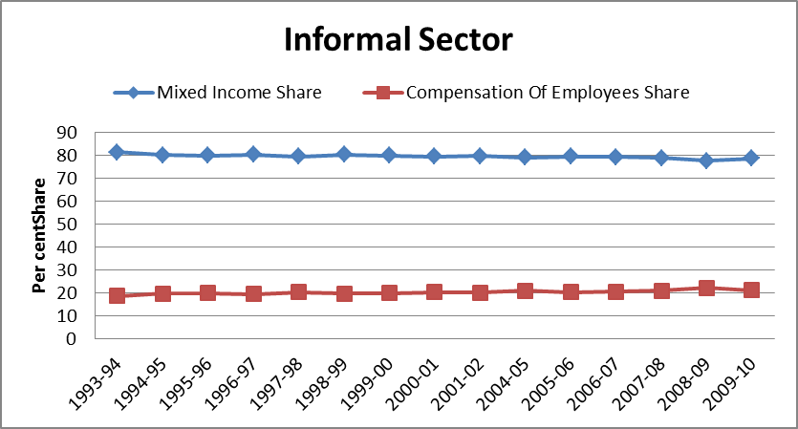
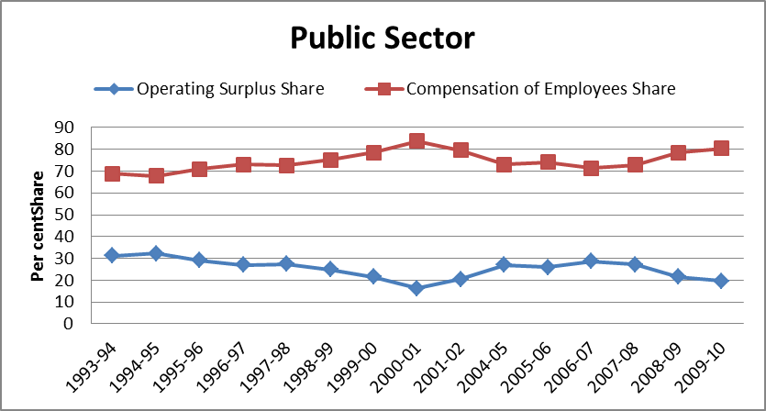
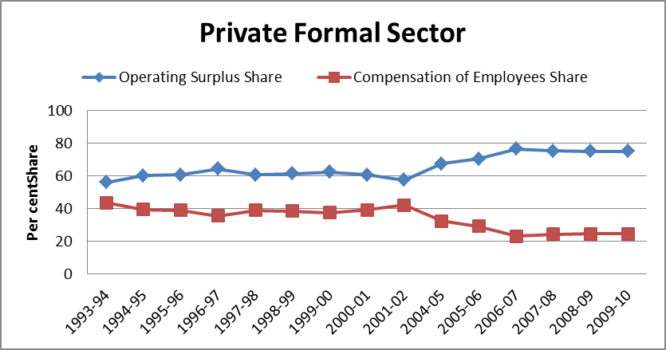
Source: Reproduced from Appendix Table A16
The informal sector is overcrowded because there is a limited scope for jobs in the formal sectors of the economy. The informal sector is also exploiting the workers by not providing any social security as well as decent work opportunities. The huge gap between mixed income and compensation of employees can justify the assumption that there are huge labour reserves in India. Those who are pushed out of agriculture due to various factors are unable to get work in the formal sector. As a result, most of the redundant labour is joining informal sector which is already overcrowded.
3.6 Summing up
The analysis shows that the long-term trend (1993 to 2011-12) explains a secular decline in the growth of overall employment. However, shorter periods (1999-2005 and 2005-2010) show fluctuations. A significant proportion of employment is contributed by agricultural sector while it registered the lowest growth particularly in a period of 1993-94 to 2011-12 (-0.36 percent). The service sector has low employment opportunities in the reform period. Examination of the intensity of employment reflects that overall economic growth in the reform period has not been employment intensive. The employment elasticity of growth has declined on the whole in the reform period barring a few sub-sectors such as trade and construction. Further, the share of self-employed workers is very high which is typically associated with a small ‘formal sector’ and a large agriculture sector along with a variety of informal livelihood options outside agriculture.
The overall employment growth rates are higher in urban India than that of rural India both for female and male workers in the reform period which were at the same level in both the region in the pre-reform period. It implies that employment prospects are relatively better in urban India during the reform period, irrespective of the quality of employment.
The shift towards the neo-liberal policies had worsened the conditions by cutting down the public sector employment. The neo-liberalism has tended to put tremendous pressure on decent job opportunities which is reflected in the form of huge labour reserves. The reform period has resulted in a high rate of GDP growth accompanied by inequality in the distribution of income. Nevertheless, the income share of the informal sector in GDP is declining; there has been an increase in share of informalisation of employment. On the contrary, the formal sector is contributing a small share of employment in the economy, regardless; it is contributing a major share of GDP. This has led to a widening of income gaps, where a large proportion of the workforce is getting a tiny share of income.
To sum up the findings, the following points can be made: India’s economic growth has not shown any adequate impact on employment generation. Further, there are few challenges to the growth story of Indian Economy in the recent years. First, employment growth has decelerated in the reform period. Second, employment content of the growth has shown a dip. Third, sectors with higher employment potential have registered relatively slower growth of output. Fourth, agricultural sector, despite a sharp decline in its importance in GDP, continues to be the largest employer as the non-agricultural sectors have not generated enough jobs to cause a shift of workforce. Fifth, most of the employment growth has been generated by the informal economy.
References
Abraham, V. (2009). Employment growth in rural India: Distress-driven?. Economic and Political Weekly, 44(16), 97-104.

⸺ (2013). Missing labour or consistent ‘de-feminisation‘? Economic and Political Weekly, 48(31), 99-108.
Bhalla, S. & Kaur, R. (2013). Labour force participation of women in India: some facts, some queries. Asia Research Center Working Paper, 40, London School of Economics and Political Science, London. Retrieved from https://core.ac.uk/download/pdf/220817.pdf. Last accessed on March 2, 2015.
Binswanger-Mkhize, H. P. (2012). India 1960-2010: Structural change, the rural non-farm sector, and the prospects for agriculture. Department of Agricultural and Resource Economics, University of California, Berkeley. Retrieved from http://are.berkeley.edu/documents/seminar/Binswanger.pdf Last accessed on February 5, 2015.
Breman, J. (1996). Footloose labour: Working in India's informal economy (Vol. 2). Cambridge University Press, USA.
Chandrasekhar, C. P. & Ghosh, J. (2007). Recent employment trends in India and China: An unfortunate convergence? The Indian Journal of Labour Economics, 50(3), 383-406.
Chen, M. A. (2005). Rethinking the informal economy: Linkages with the formal economy and the formal regulatory environment. Research paper, UNU-WIDER, United Nations University (UNU), No. 2005/10. Retrieved from https://www.econstor.eu/bitstream/10419/63329/1/488006546.pdf. Last accessed on December 4, 2015.
Deshingkar, P. (2009). Extending labour inspections to the informal sector and agriculture. Working Paper No. 154, Chronic Poverty Research Centre, United Kingdom.
Gill, S. S. (2012). Distribution of income and share of wages in India: labour under globalising economy. The Indian Journal of Labour Economics, 55(1), 1-21.
Gupta, J. (2003). Informal labour in brick kilns: Need for regulation. Economic and Political Weekly, 38(31), 3282-3292.
Harriss-White, B., & Gooptu, N. (2009). Mapping India's world of unorganized labour. Socialist Register, 37(37), 89-118.

Harris-White, B., & Sinha, A. (2007). Trade liberalization and India's informal economy. Oxford University Press.
Himanshu, Lanjouw, P., Mukhopadhyay, A., & Murgai, R. (2011). Non-farm diversification and rural poverty decline: A perspective from Indian sample survey and village study data. LSE Asia Research Centre, Working Paper 44, London, United Kingdom. Retrieved from http://eprints.lse.ac.uk/38371/1/ARCWP44-HimanshuLanjouwMukhopadhyayMurgai.pdf. Last accessed on January 15, 2015.
Hirway, I. (2012). Missing labour force: An explanation. Economic and Political Weekly, 47(37), 67-72.
Hsiao, F. S., & Mei-Chu, W. H. (2003). ―Miracle Growth‖ in the twentieth century ––international comparisons of East Asian development. World Development, 31(2), 227-257.
Jha, B. (2006). Rural non-farm employment in India: Macro-trends, micro-evidences and policy options. Research Paper, Institute of Economic Growth, New Delhi.
Jha, P. & Thakur, A. N. (2012). Structural transformation of Bihar‘s economy since early 1980s: all dressed up but where to go? Journal of Social and Economic Studies, 22(2), 5-46.
Jha, P. (2003). Issues relating to employment in India in the era of globalisation. Social Scientist, 31(11/12), 47-65.
⸺ (2010). Labour regulation and economic performance: What do we know?. The Indian Journal of Labour Economics, 53(1), 89-111.
⸺ (2016). Labour in Contemporary India. Oxford University Press, New Delhi.
Jomo, K. S. (1990). Growth and structural change in Malaysian economy. Macmillan, USA.
Kannan, K. P., & Raveendran, G. (2012). Counting and profiling the missing labour force. Economic and Political Weekly, 47(6), 77-80.
Korinek, K., & Loebach, P. (2016). Migrant networks, immigrant and ethnic economies, and destination development. The Sociology of Development Handbook, 362.
Mamgain, R. P., & Awasthi, I. C. (2001). Technology and training for informal sector: Need for new initiatives. In A. Kundu & A. Sharma (Eds.), Informal sector in India: Perspectives and policies (363-380). Institute for Human Development and Institute of Applied Manpower Research, New Delhi.
Mazumdar, I. & Neetha N. (2011). Gender dimensions: Employment trends in India, 1993-94 to 2009-10. Occasional Paper No.56, Centre for Women‘s Development Studies, New Delhi.
Moyo, S., Jha, P., & Yeros, P. (2013). The classical agrarian question: Myth, reality and relevance today. Agrarian South: Journal of Political Economy, 2(1), 93-119.
National Commission for Enterprises in the Unorganised Sector (NCEUS) (2008a). Report on conditions of work and promotion of livelihood in the unorganised sector. Government of India, Academic Foundation, New Delhi.
NSSO (1984). Employment and Unemployment in India, (38/10). Ministry of Statistics & Programme Implementation. Government of India, New Delhi. 229

⸺⸻⸻ (1996). Key Results on Employment and Unemployment, Revised Report No. 406. Ministry of Statistics & Programme Implementation. Government of India, New Delhi.

⸺⸻⸻ (1997). Employment and Unemployment in India, 1993-94, Report No. 409. Ministry of Statistics & Programme Implementation. Government of India, New Delhi.

⸺⸻⸻ (1999-00). Unit-level data, Employment and Unemployment Survey (55th Round, schedule 10). Ministry of Statistics & Programme Implementation. Government of India, New Delhi.

⸺⸻⸻ (2000). Employment and Unemployment in India, 1999-2000, 455(55/10/1). Ministry of Statistics & Programme Implementation. Government of India, New Delhi.

⸺⸻⸻ (2001). Employment and Unemployment Situation in India, 458(55/10/2). Ministry of Statistics & Programme Implementation. Government of India, New Delhi.

⸺⸻⸻ (2001). Non-agricultural workers in informal sector based on Employment - Unemployment survey 1999-2000, 460(55/10/3). Ministry of Statistics & Programme Implementation. Government of India, New Delhi.

⸺⸻⸻ (2004-05). Unit-level data, Employment and Unemployment Survey (61st Round, schedule 10). Ministry of Statistics & Programme Implementation. Government of India, New Delhi.

⸺⸻⸻ (2006). Employment and Unemployment Situation in India, 515(61/10/1). Ministry of Statistics & Programme Implementation. Government of India, New Delhi.
⸺⸻⸻ (2009-10). Unit-level data, Employment and Unemployment Survey (66th Round, schedule 10). Ministry of Statistics & Programme Implementation. Government of India, New Delhi.

⸺⸻⸻ (2011). Key indicators of Employment and Unemployment Situation in India, (68/10). Ministry of Statistics & Programme Implementation. Government of India, New Delhi.

⸺⸻⸻ (2011-12). Unit-level data, Employment and Unemployment Survey (68th Round, schedule 10). Ministry of Statistics & Programme Implementation. Government of India, New Delhi.

⸺⸻⸻ (2014). Informal Sector and Conditions of Employment in India, 557(68/10/2). Ministry of Statistics & Programme Implementation. Government of India, New Delhi.

⸺⸻⸻ (2014). Key Indicators of Employment and Unemployment Situation in India, 554(68/10/1). Ministry of Statistics & Programme Implementation. Government of India, New Delhi.

Papola, T. S. & Sahu, P. P. (2012). Growth and structure of employment: Long term and post-reform performance and the emerging challenge. Occasional Paper No. 2012/01, Institute for Industrial Development, New Delhi.
Papola, T.S. (2007). Employment in the development agenda: Economic and social policies. International Institute for Labour Studies. Retrieved from http://natlex.ilo.ch/wcmsp5/groups/public/---dgreports/---inst/ documents/ publication/ wcms_193520.pdf. Last accessed on March 1, 2013.
Patnaik, P. (2007a). Contemporary imperialism and the world's labour reserves. Social Scientist, 35(5/6), 3-18.
⸺ (2007b). The state under neo-liberalism. Social Scientist, 35(1/2), 4-15.
Rangarajan, C, Iyer, P. & Kaul, S. (2011). Where is the missing labour force? Economic and Political Weekly, 46(39), 68-72.
Rani, U., & Unni, J. (2009). Do economic reforms influence home-based work? Evidence from India. Feminist Economics, 15(3), 191-225.
Raveendran, G., Sudarshan, R. M., & Vanek, J. (2013). Home-based workers in India: Statistics and trends. WIEGO Statistical Brief, (10). Retrieved from http://www.homenetsouthasia.net/pdf/stat_2015/Statistical%20Brief-India .pdf. Last accessed on May 24, 2015.
Srivastava, N. & Srivastava, R. (2010). Women, work, and employment outcomes in rural India. Economic and political weekly, 45(28), 49-63.
Srivastava, R. S. & Jha, A. (2016). Capital and labour standards in the organized construction industry in India: A study based on fieldwork in the Nation Capital Region of Delhi. Centre for the Study of Regional Development, JNU, New Delhi. Retrieved from https://www.soas.ac.uk/cdpr/ publications/ reports/file111602.pdf Last accessed on March 2, 2017.
Studwell, J. (2013). How Asia works: Success and failure in the world's most dynamic region. Grove Press, New York.
Sundaram, K., & Tendulkar, S. D. (2002). The working poor in India: Employment-poverty linkages and employment policy options (Vol. 4). International Labour Office, Recovery and Reconstruction Department. Retrieved from http://www.ipc-undp.org/conference/emprego/paper /india. pdf. Last accessed on May 4, 2012.
Unni, J., & Raveendran, G. (2007). Growth of employment (1993-94 to 2004-05): Illusion of inclusiveness?. Economic and Political Weekly, 42(3), 196-199.

Appendix
Table A1: All India Workforce participation rate by UPSS, in percent
Year (NSS Round) | Rural | Urban | All
1977-78 (32nd) | 44.4 | 34.1 | 42.3
1983 (38th) | 44.5 | 34.0 | 42.0
1987-88 (43rd) | 43.4 | 33.7 | 41.2
1993-94 (50th) | 44.4 | 34.7 | 42.0
1999-00 (55th) | 41.7 | 33.7 | 39.7
2004-05 (61st) | 43.9 | 36.5 | 42.0
2009-10 (66th) | 40.8 | 35.0 | 39.2
2011-12 (68th) | 39.9 | 35.5 | 38.6
Source: Employment and Unemployment Survey, NSS (various rounds).
Table A2: Growth Rate of Employment across Major Sectors
Major sectors | 1983 to 1987-88 | 1987-88 to 1993-94 | 1993-94 to 1999-00 | 1999-00 to 2004-05 | 2004- 05 to 2009-10 | 2009-10 to 2011-12 | 1983 to 1993-94 | 1993-94 to 2011-12 | 1983 to 2011-12
Agriculture | 1.01 | 2.19 | 0.08 | 1.38 | -1.64 | -2.82 | 1.72 | -0.36 | 0.38
Mining & Quarrying | 5.72 | 2.31 | -2.67 | 2.40 | 2.95 | -7.52 | 3.67 | -0.24 | 1.16
Manufacturing | 2.14 | 1.57 | 1.76 | 4.98 | -1.07 | 7.03 | 1.80 | 2.45 | 2.22
Electricity etc. | 6.85 | 2.95 | -4.64 | 3.22 | 1.01 | 35.57 | 4.51 | 3.58 | 3.91
Construction | 14.25 | -0.20 | 6.34 | 7.90 | 10.69 | 5.90 | 5.58 | 7.93 | 7.09
Industry | 4.79 | 1.24 | 2.57 | 5.70 | 3.40 | 6.66 | 2.66 | 4.12 | 3.60
Trade | 3.98 | 3.31 | 6.29 | 3.98 | 1.09 | 1.02 | 3.58 | 3.62 | 3.60
Transport etc. | 2.56 | 3.47 | 5.42 | 4.86 | 2.11 | 6.40 | 3.10 | 4.46 | 3.97
Other Services | 2.26 | 4.44 | -0.49 | 3.66 | 1.63 | 4.71 | 3.57 | 1.83 | 2.45
Services | 2.93 | 3.89 | 3.08 | 3.99 | 1.47 | 3.46 | 3.51 | 2.93 | 3.13
Nonfarm | 3.8 | 2.7 | 2.9 | 4.7 | 2.3 | 4.9 | 3.1 | 3.5 | 3.3
All | 1.89 | 2.35 | 1.11 | 2.79 | 0.21 | 1.07 | 2.16 | 1.32 | 1.62
Source: Computed from Employment and Unemployment Survey, NSS (various rounds).

Table A3: Growth of GDP (at constant 1999‐2000 Price) from 1983 to 2011-12
Major sectors | 1983 to 1987-88 | 1987-88 to 1993-94 | 1993-94 to 1999-00 | 1999-00 to 2004-05 | 2004- 05 to 2009-10 | 2009-10 to 2011-12 | 1983 to 1993-94 | 1993-94 to 2011-12 | 1983 to 2011-12
Agriculture | -0.03 | 4.56 | 3.26 | 1.57 | 3.12 | 5.61 | 2.73 | 3.01 | 2.91
Mining & Quarrying | 5.43 | 6.31 | 5.23 | 4.50 | 4.00 | 2.08 | 5.96 | 4.33 | 4.91
Manufacturing | 4.51 | 5.02 | 7.02 | 5.84 | 9.55 | 5.97 | 4.82 | 7.28 | 6.40
Electricity etc. | 8.80 | 8.04 | 6.72 | 4.17 | 6.84 | 5.67 | 8.34 | 5.92 | 6.79
Construction | 4.21 | 5.13 | 6.17 | 8.94 | 8.75 | 7.57 | 4.76 | 7.81 | 6.72
Industry | 4.83 | 5.44 | 6.58 | 6.36 | 8.62 | 6.10 | 5.19 | 7.03 | 6.37
Trade | 5.50 | 5.39 | 8.89 | 7.57 | 8.96 | 8.44 | 5.43 | 8.49 | 7.40
Transport etc. | 6.48 | 5.45 | 9.79 | 10.36 | 11.76 | 10.47 | 5.86 | 10.57 | 8.89
Other Services | 7.39 | 6.85 | 7.66 | 5.52 | 9.73 | 8.05 | 7.07 | 7.68 | 7.46
Services | 6.70 | 6.25 | 8.28 | 6.84 | 9.84 | 8.59 | 6.43 | 8.35 | 7.66
Nonfarm | 5.96 | 5.94 | 7.66 | 6.67 | 9.43 | 7.78 | 5.95 | 7.89 | 7.20
All | 3.91 | 5.49 | 6.48 | 5.60 | 8.37 | 7.47 | 4.86 | 6.87 | 6.15
Source: Computed from National Accounts Statistics, CSO (various years).

Table A4: Employment Elasticity With Respect to GDP
Major sectors | 1983 to 1987-88 | 1987-88 to 1993-94 | 1993-94 to 1999-00 | 1999-00 to 2004-05 | 2004- 05 to 2009-10 | 2009-10 to 2011-12 | 1983 to 1993-94 | 1993-94 to 2011-12 | 1983 to 2011-12
Agriculture | -33.67 | 0.48 | 0.02 | 0.88 | -0.53 | -0.50 | 0.63 | -0.12 | 0.13
Mining & Quarrying | 1.05 | 0.37 | -0.51 | 0.53 | 0.74 | -3.62 | 0.62 | -0.06 | 0.24
Manufacturing | 0.47 | 0.31 | 0.25 | 0.85 | -0.11 | 1.18 | 0.37 | 0.34 | 0.35
Electricity etc. | 0.78 | 0.37 | -0.69 | 0.77 | 0.15 | 6.27 | 0.54 | 0.60 | 0.58
Construction | 3.38 | -0.04 | 1.03 | 0.88 | 1.22 | 0.78 | 1.17 | 1.02 | 1.06
Industry | 0.99 | 0.23 | 0.39 | 0.90 | 0.39 | 1.09 | 0.51 | 0.59 | 0.57
Trade | 0.72 | 0.61 | 0.71 | 0.53 | 0.12 | 0.12 | 0.66 | 0.43 | 0.49
Transport etc. | 0.40 | 0.64 | 0.55 | 0.47 | 0.18 | 0.61 | 0.53 | 0.42 | 0.45
Other Services | 0.31 | 0.65 | -0.06 | 0.66 | 0.17 | 0.59 | 0.50 | 0.24 | 0.33
Services | 0.44 | 0.62 | 0.37 | 0.58 | 0.15 | 0.40 | 0.55 | 0.35 | 0.41
Nonfarm | 0.64 | 0.45 | 0.38 | 0.70 | 0.24 | 0.63 | 0.52 | 0.44 | 0.46
All | 0.48 | 0.43 | 0.17 | 0.50 | 0.03 | 0.14 | 0.44 | 0.19 | 0.26
Source: Computed from Employment and Unemployment Survey, NSS and National Accounts Statistics, CSO, (various years)

Table A5: Growth Rate of Employment across Major Sectors in Rural India
Rural sector | 1983 to 1987-88 |  | 1987-88 to 1993-94 |  | 1993-94 to 1999-00 |  | 1999-00 to 2004-05 |  | 2004- 05 to 2009-10 |  | 2009-10 to 2011-12 |  | 1983 to 1993-94 |  | 1993-94 to 2011-12 |  | 1983 to 2011-12
Rural sector | M | F | M | F | M | F | M | F | M | F | M | F | M | F | M | F | M | F
Agriculture | 0.7 | 1.7 | 2.4 | 1.9 | 0.3 | 0.0 | 0.4 | 2.6 | 0.0 | -4.3 | -2.0 | -4.3 | 1.7 | 1.8 | 0.0 | -1.0 | 0.6 | 0.0
Mining & Quarrying | 5.6 | 9.7 | 2.5 | 1.6 | -1.6 | -4.6 | 1.8 | 3.1 | 6.9 | -3.3 | -22.7 | -1.4 | 3.7 | 4.9 | -0.6 | -1.8 | 0.9 | 0.6
Manufacturing | 3.1 | 4.4 | 1.6 | 1.9 | 1.6 | 1.5 | 3.4 | 5.1 | -1.2 | -5.6 | 8.1 | 12.0 | 2.2 | 2.9 | 2.0 | 1.7 | 2.1 | 2.1
Electricity etc. | 11.9 | - | 2.5 | - | -5.8 | - | 1.8 | - | 1.2 | - | 21.1 |  | 6.2 | - | 1.2 | - | 3.0 | -
Construction | 14.7 | 36.2 | 0.1 | -16.7 | 6.6 | 3.5 | 10.1 | 9.3 | 11.3 | 21.5 | 7.8 | 10.5 | 5.9 | 4.5 | 9.0 | 10.9 | 7.9 | 8.6
Industry | 6.5 | 10.0 | 1.2 | -1.5 | 2.9 | 1.5 | 6.0 | 5.6 | 5.6 | 1.5 | 7.1 | 11.4 | 3.3 | 3.1 | 5.0 | 3.8 | 4.4 | 3.5
Trade | 5.4 | 5.0 | 3.7 | 1.6 | 4.5 | -0.7 | 5.8 | 7.6 | 0.9 | -1.1 | -0.5 | 2.1 | 4.4 | 3.0 | 3.3 | 1.8 | 3.7 | 2.2
Transport etc. | 5.8 | 2.5 | 4.1 | 1.6 | 7.2 | 0.2 | 5.3 | 17.0 | 2.7 | -3.3 | 2.0 | -1.4 | 4.8 | 2.0 | 4.8 | 3.7 | 4.8 | 3.1
Other Services | 2.1 | 4.2 | 4.5 | 3.7 | -1.4 | 1.6 | 1.1 | 4.1 | -0.2 | 0.0 | 8.4 | 4.8 | 3.6 | 3.9 | 0.7 | 2.2 | 1.7 | 2.8
Services | 3.9 | 4.5 | 4.2 | 2.9 | 2.5 | 0.7 | 4.0 | 5.7 | 1.0 | -0.5 | 3.0 | 3.6 | 4.0 | 3.5 | 2.5 | 2.1 | 3.1 | 2.6
Nonfarm | 5.1 | 8.0 | 2.8 | 0.2 | 2.7 | 1.2 | 4.9 | 5.6 | 3.2 | 0.7 | 5.2 | 8.7 | 3.7 | 3.3 | 3.7 | 3.1 | 3.7 | 3.2
All | 1.7 | 2.5 | 2.5 | 1.6 | 0.9 | 0.2 | 1.8 | 3.1 | 1.2 | -3.3 | 0.8 | -1.4 | 2.2 | 2.0 | 1.2 | -0.2 | 1.6 | 0.6
Source: Computed from Employment and Unemployment Survey, NSS (various rounds).
Table A6: Growth Rate of Employment across Major Sectors in Urban India
Urban sector | 1983 to 1987-88 |  | 1987-88 to 1993-94 |  | 1993-94 to 1999-00 |  | 1999-00 to 2004-05 |  | 2004- 05 to 2009-10 |  | 2009-10 to 2011-12 |  | 1983 to 1993-94 |  | 1993-94 to 2011-12 |  | 1983 to 2011-12
Urban sector | M | F | M | F | M | F | M | F | M | F | M | F | M | F | M | F | M | F
Agriculture | -1.4 | -0.6 | 2.7 | 0.3 | -2.2 | -4.2 | 2.3 | 7 | 2.1 | -6.1 | -0.6 | -6.1 | 1.1 | -0.1 | 0.4 | -1.8 | 0.7 | -1.2
Mining & Quarrying | 3.7 | 8 | 2.9 | -1.6 | -3.2 | -5.4 | 3.9 | -7.3 | -2.6 | 7.3 | 15.5 | 6.1 | 3.2 | 2.2 | 1 | -1.1 | 1.8 | 0.1
Manufacturing | 0.6 | 1.1 | 1.5 | 1.3 | 2.1 | 1.3 | 4.8 | 9.8 | 0.9 | -1 | 4.2 | 7.5 | 1.2 | 1.2 | 2.8 | 3.7 | 2.2 | 2.8
Electricity etc. | 3.9 | 0.8 | 2.9 | 10 | -3.8 | -5.4 | 3.9 | 6.5 | -0.3 | 13.1 | 37.5 | 51.9 | 3.3 | 6.3 | 3.9 | 9.4 | 3.7 | 8.3
Construction | 4.9 | 5.2 | 5.8 | 4.9 | 6.9 | 4 | 5 | 1.9 | 6.7 | 3.5 | -0.3 | -2 | 5.5 | 5 | 5.5 | 2.6 | 5.5 | 3.5
Industry | 1.5 | 1.7 | 2.4 | 1.8 | 2.9 | 1.5 | 4.8 | 8.5 | 2.5 | -0.2 | 4 | 7.1 | 2.1 | 1.7 | 3.5 | 3.6 | 3 | 2.9
Trade | 3.1 | 1.6 | 3.2 | 3.5 | 7.9 | 10.1 | 2.9 | 0 | 1.7 | -0.9 | 1 | 8.9 | 3.2 | 2.7 | 4 | 4.1 | 3.7 | 3.6
Transport etc. | 1.2 | -12 | 2.9 | 9.3 | 4.1 | 6.8 | 4.5 | 1.5 | 1.8 | -0.8 | 8.8 | 38.9 | 2.2 | 0.8 | 4.1 | 6.8 | 3.4 | 4.7
Other Services | 2.1 | 1.9 | 3.7 | 7 | -0.8 | 1 | 3.7 | 7.5 | 3.4 | 1 | 1.7 | 6.5 | 3.1 | 5 | 1.9 | 3.4 | 2.3 | 4
Services | 2.3 | 1.4 | 3.4 | 6.3 | 3.8 | 3.6 | 3.5 | 5.2 | 2.3 | 0.5 | 2.7 | 8.2 | 3 | 4.3 | 3.2 | 3.7 | 3.1 | 3.9
Nonfarm | 2.0 | 1.5 | 3.0 | 4.4 | 3.5 | 2.8 | 3.9 | 6.4 | 2.4 | 0.2 | 3.2 | 7.8 | 2.6 | 3.2 | 3.3 | 3.7 | 3.0 | 3.5
All | 1.7 | 0.8 | 2.9 | 3.2 | 3 | 1.4 | 3.9 | 6.5 | 2.4 | -0.8 | 2.9 | 6.1 | 2.4 | 2.2 | 3.1 | 2.7 | 2.8 | 2.6
Source: Computed from Employment and Unemployment Survey, NSS (various rounds).

Table A7: Percentage Distribution of Employment by 2 digit Industry Level (UPSS) by Gender in Rural India
Rural sector | 1977-78 |  | 1983 |  | 1987-88 |  | 1993-94 |  | 1999-00 |  | 2004-05 |  | 2009-10 |  | 2011-12
Rural sector | M | F | M | F | M | F | M | F | M | F | M | F | M | F | M | F
Agriculture | 80.6 | 88.1 | 77.5 | 87.5 | 74.5 | 84.7 | 74.1 | 86.2 | 71.4 | 85.4 | 66.5 | 83.3 | 62.8 | 79.4 | 59.4 | 74.9
Mining and Quarrying | 0.5 | 0.2 | 0.6 | 0.3 | 0.7 | 0.4 | 0.7 | 0.4 | 0.6 | 0.3 | 0.6 | 0.3 | 0.8 | 0.3 | 0.5 | 0.3
Manufacturing | 6.4 | 5.9 | 7 | 6.4 | 7.4 | 6.9 | 7 | 7 | 7.3 | 7.6 | 7.9 | 8.4 | 7 | 7.5 | 8.1 | 9.8
Electricity, water etc. | 0.2 | 0 | 0.2 | 0 | 0.3 | 0 | 0.3 | 0 | 0.2 | 0 | 0.2 | 0 | 0.2 | 0 | 0.3 | 0.1
Construction | 1.7 | 0.6 | 2.2 | 0.7 | 3.7 | 2.7 | 3.2 | 0.9 | 4.5 | 1.1 | 6.8 | 1.5 | 11.3 | 5.2 | 13 | 6.6
Industry | 8.8 | 6.7 | 10 | 7.4 | 12.1 | 10 | 11.2 | 8.3 | 12.6 | 9 | 15.5 | 10.2 | 19.3 | 13 | 21.9 | 16.8
Trade | 4 | 2 | 4.4 | 1.9 | 5.1 | 2.1 | 5.5 | 2.1 | 6.8 | 2 | 8.3 | 2.5 | 8.2 | 2.8 | 8 | 3
Transport, storage etc. | 1.2 | 0.1 | 1.7 | 0.1 | 2 | 0.1 | 2.2 | 0.1 | 3.2 | 0.1 | 3.8 | 0.2 | 4.1 | 0.2 | 4.2 | 0.2
Other Services | 5.3 | 3 | 6.1 | 2.8 | 6.2 | 3 | 7 | 3.4 | 6.1 | 3.7 | 5.9 | 3.9 | 5.5 | 4.6 | 6.4 | 5.2
Services | 10.5 | 5.1 | 12.2 | 4.8 | 13.3 | 5.2 | 14.7 | 5.6 | 16.1 | 5.8 | 18 | 6.6 | 17.8 | 7.6 | 18.6 | 8.4
Nonfarm | 19.3 | 11.8 | 22.2 | 12.2 | 25.4 | 15.2 | 25.9 | 13.9 | 28.7 | 14.8 | 33.5 | 16.8 | 37.1 | 20.6 | 40.5 | 25.2
All | 100 | 100 | 100 | 100 | 100 | 100 | 100 | 100 | 100 | 100 | 100 | 100 | 100 | 100 | 100 | 100
Source: Computed from Employment and Unemployment Survey, NSS (various rounds).

Table A8: percentage distribution of employment by 2 digit industry level (UPSS) by gender in urban India
Urban sector | 1977-78 |  | 1983 |  | 1987-88 |  | 1993-94 |  | 1999-00 |  | 2004-05 |  | 2009-10 |  | 2011-12
Urban sector | M | F | M | F | M | F | M | F | M | F | M | F | M | F | M | F
Agriculture | 10.6 | 31.9 | 10.3 | 31 | 9.1 | 29.4 | 9 | 24.7 | 6.6 | 17.7 | 6.1 | 18.1 | 6 | 13.9 | 5.6 | 10.9
Mining and Quarrying | 0.9 | 0.5 | 1.2 | 0.6 | 1.3 | 0.8 | 1.3 | 0.6 | 0.9 | 0.4 | 0.9 | 0.2 | 0.7 | 0.3 | 0.9 | 0.3
Manufacturing | 27.6 | 29.6 | 26.8 | 26.7 | 25.7 | 27 | 23.6 | 24.1 | 22.4 | 24 | 23.5 | 28.2 | 21.8 | 27.9 | 22.4 | 28.7
Electricity, water etc. | 1.1 | 0.1 | 1.1 | 0.2 | 1.2 | 0.2 | 1.2 | 0.3 | 0.8 | 0.2 | 0.8 | 0.2 | 0.7 | 0.4 | 1.4 | 1.0
Construction | 4.2 | 2.2 | 5.1 | 3.1 | 5.8 | 3.7 | 6.9 | 4.1 | 8.7 | 4.8 | 9.2 | 3.8 | 11.4 | 4.7 | 10.7 | 4
Industry | 33.8 | 32.4 | 34.2 | 30.6 | 34 | 31.7 | 33 | 29.1 | 32.8 | 29.4 | 34.4 | 32.4 | 34.6 | 33.3 | 35.4 | 34
Trade | 21.6 | 8.7 | 20.3 | 9.5 | 21.5 | 9.8 | 21.9 | 10 | 29.4 | 16.9 | 28 | 12.2 | 27 | 12.1 | 26 | 12.8
Transport, storage etc. | 9.8 | 1.0 | 9.9 | 1.5 | 9.7 | 0.9 | 9.7 | 1.3 | 10.4 | 1.8 | 10.7 | 1.4 | 10.4 | 1.4 | 11.7 | 2.7
Other Services | 24.3 | 26 | 24.8 | 26.6 | 25.2 | 27.8 | 26.4 | 35 | 21 | 34.2 | 20.8 | 35.9 | 21.9 | 39.3 | 21.4 | 39.6
Services | 55.7 | 35.7 | 55 | 37.6 | 56.4 | 38.5 | 58 | 46.3 | 60.8 | 52.9 | 59.5 | 49.5 | 59.3 | 52.8 | 59.1 | 55.1
Nonfarm | 89.5 | 68.1 | 89.2 | 68.2 | 90.4 | 70.2 | 91 | 75.4 | 93.6 | 82.3 | 93.9 | 81.9 | 93.9 | 86.1 | 94.5 | 89.1
All | 100 | 100 | 100 | 100 | 100 | 100 | 100 | 100 | 100 | 100 | 100 | 100 | 100 | 100 | 100 | 100
Source: Computed from Employment-Unemployment Surveys, NSS (Various years)

Table A9: Sectoral Share of GDP from 1983 to 2011-12
Major sectors | 1983 | 1987 | 1993 | 1999-00 | 2004-05 | 2009-10 | 2011-12
Agriculture | 35.0 | 29.9 | 28.2 | 23.3 | 19.0 | 14.6 | 14.1
Mining and Quarrying | 2.9 | 3.1 | 3.3 | 3.0 | 2.9 | 2.3 | 2.1
Manufacturing | 14.7 | 15.0 | 14.6 | 15.1 | 15.3 | 16.2 | 15.7
Electricity, water etc. | 1.6 | 1.9 | 2.2 | 2.3 | 2.1 | 2.0 | 1.9
Construction | 6.7 | 6.8 | 6.6 | 6.5 | 7.7 | 7.8 | 7.9
Industry | 25.9 | 26.8 | 26.7 | 26.9 | 27.9 | 28.3 | 27.5
Trade | 11.9 | 12.7 | 12.6 | 14.6 | 16.1 | 16.5 | 16.9
Transport, storage etc. | 4.9 | 5.5 | 5.4 | 6.6 | 8.4 | 10.0 | 10.6
Other Services | 21.4 | 24.6 | 26.7 | 28.7 | 28.6 | 30.6 | 30.9
Services | 38.3 | 42.8 | 44.8 | 49.9 | 53.0 | 57.1 | 58.4
Nonfarm | 64.2 | 69.6 | 71.5 | 76.8 | 80.9 | 85.4 | 85.9
All | 100.0 | 100.0 | 100.0 | 100.0 | 100.0 | 100.0 | 100.0
Source: Computed from National Accounts Statistics, CSO (Various years)
Table A10: Percentage Distribution of Type of Employment in India since 1983
Year (NSS Round) | 1983 (38th) | 1987-88 (43rd) | 1993-94 (50th) | 1999-00 (55th) | 2004-05 (61st) | 2009-10 (66th) | 2011-12 (68th)
Rural males
Self-employed | 60.5 | 58.6 | 57.7 | 55 | 58.1 | 53.5 | 54.5
regular wage/salaried | 10.3 | 10 | 8.5 | 8.8 | 9 | 8.5 | 10
Casual | 29.2 | 31.4 | 33.8 | 36.2 | 32.9 | 38 | 35.5
Rural females
Self-employed | 61.9 | 60.8 | 58.6 | 57.3 | 63.7 | 55.7 | 59.3
regular wage/salaried | 2.8 | 3.7 | 2.7 | 3.1 | 3.7 | 4.4 | 5.6
Casual | 35.3 | 35.5 | 38.7 | 39.6 | 32.6 | 39.9 | 35.1
Urban Males
Self-employed | 40.9 | 41.7 | 41.7 | 41.5 | 44.8 | 41.1 | 41.7
regular wage/salaried | 43.7 | 43.7 | 42 | 41.7 | 40.6 | 41.9 | 43.4
Casual | 15.4 | 14.6 | 16.3 | 16.8 | 14.6 | 17 | 14.9
Urban Females
Self-employed | 45.8 | 47.1 | 45.8 | 45.3 | 47.7 | 41.1 | 42.8
regular wage/salaried | 25.8 | 27.5 | 28.4 | 33.3 | 35.6 | 39.3 | 42.8
Casual | 28.4 | 25.4 | 25.8 | 21.4 | 16.7 | 19.6 | 14.3
Source: Employment and Unemployment Survey, NSS (various rounds).
Table A11: Relationship between Sector and Type of Employment (UPSS), 1999-00 to 2011-12
Sector/Worker | Total Employment (Million)
Sector/Worker | Informal Workers | Formal Workers | Total Workers
1999-2000 (NSS 55th Round)
Informal Sector | 341.3 (99.6) | 1.4 (0.4) | 342.6 (100.0)
Formal Sector | 20.5(37.8) | 33.7 (62.2) | 54.1 (100.0)
Total | 361.7 (91.2) | 35.0 (8.8) | 396.8 (100.0)
2004-05 (NSS 61st Round)
Informal Sector | 393.5 (99.6) | 1.4 (0.4) | 394.9 (100.0)
Formal Sector | 29.1 (46.6) | 33.4 (53.4) | 62.6 (100.0)
Total | 422.6 (92.4) | 34.9 (7.6) | 457.5 (100.0)
2009-10 (NSS 66th Round)
Informal Sector | 388.0 (99.6) | 1.6 (0.4) | 389.6 (100.0)
Formal Sector | 36.9 (52.3) | 33.5 (47.6) | 70.5 (100.0)
Total | 425.0 (92.3) | 35.1 (7.65) | 460.2 (100.0)
2011-12 (NSS 68th Round)
Informal Sector | 403.8 (99.7) | 1.4 (0.3) | 405.2 (100.0)
Formal Sector | 43.4 (54.4) | 36.1 (45.5) | 79.5 (100.0)
Total | 447.2 (92.2) | 37.5 (7.7) | 484.7 (100.0)
Source: 1. Computed from NSS Unit-level Data on Employment and Unemployment, NSS(2011-12)
2. Figure for 55th and 61st round are adopted from the Report on Conditions of Work and Promotion of Livelihoods in the Unorganised Sector, 2007.
Note: Figures in parenthesis are percentages.

Table A12 Informal Workers across Major Sectors, 1999-00 to 2011-12 (in million)
Major sectors | 1999-00  (55th Round) |  | 2004-05  (61st round) |  | 2011-12  (68th Round)
Major sectors | Informal | Formal | Informal | Formal | Informal | Formal
Agriculture | 234.79 | 2.89 | 256.07 | 2.86 | 231.37 | 0.24
Agriculture | (98.78) | (1.22) | (98.90) | (1.10) | (99.90) | (0.10)
Mining and Quarrying | 1.56 | 0.61 | 1.78 | 0.86 | 1.80 | 0.76
Mining and Quarrying | (71.89) | (28.11) | (67.42) | (32.58) | (70.35) | (29.65)
Manufacturing | 36.85 | 7.20 | 49.30 | 6.48 | 52.94 | 6.76
Manufacturing | (83.65) | (16.35) | (88.38) | (11.62) | (88.68) | (11.32)
Electricity, water etc. | 0.21 | 0.92 | 0.24 | 1.06 | 1.25 | 1.19
Electricity, water etc. | (18.58) | (81.42) | (18.46) | (81.54) | (51.27) | (48.73)
Construction | 16.90 | 0.63 | 25.32 | 0.70 | 48.90 | 1.29
Construction | (96.41) | (3.59) | (97.31) | (2.69) | (97.42) | (2.58)
Industry | 55.52 | 9.36 | 76.64 | 9.10 | 104.89 | 10.00
Industry | (85.57) | (14.43) | (89.39) | (10.61) | (91.29) | (8.71)
Trade | 35.41 | 1.21 | 42.54 | 0.82 | 42.89 | 1.23
Trade | (96.70) | (3.30) | (98.11) | (1.89) | (97.20) | (2.80)
Transport, storage etc | 11.44 | 3.17 | 15.28 | 3.20 | 18.24 | 4.65
Transport, storage etc | (78.30) | (21.70) | (82.68) | (17.32) | (79.68) | (20.32)
Other Services | 24.58 | 18.37 | 32.09 | 18.89 | 39.56 | 20.56
Other Services | (57.23) | (42.77) | (60.87) | (35.83) | (65.80) | (34.20)
Services | 71.43 | 22.75 | 89.91 | 22.91 | 100.69 | 26.45
Services | (75.84) | (24.16) | (77.37) | (19.71) | (79.20) | (20.80)
Nonfarm | 126.95  (79.81) | 32.11  (20.19) | 166.55  (83.88) | 32.01  (16.12) | 205.58  (84.94) | 36.45  (15.06)
All | 361.74 | 35.02 | 422.61 | 34.85 | 436.95 | 36.69
All | (91.17) | (8.83) | (91.85) | (7.57) | (92.25) | (7.75)
Source: 1. Computed from NSS Unit-level Data on Employment and Unemployment, NSS(2011-12)
2. Figure for 55th and 61st round are adopted from the Report on Conditions of Work and Promotion of Livelihoods in the Unorganised Sector, 2007.
Note: Figures in parenthesis are percent

Table A13: Share of Informal Workers since 1999-2000, State-wise (in percent)
State | Informal Workers
State | 1999-2000 | 2004-05 | 2011-12
Andhra Pradesh | 92.2 | 94.0 | 93.1
Assam | 85.3 | 90.2 | 93.1
Bihar | 95.4 | 97.5 | 96.9
Gujarat | 91.4 | 91.6 | 92.0
Haryana | 87.5 | 90.2 | 87.1
Himachal Pradesh | 91.2 | 90.2 | 90.7
Jammu & Kashmir | 89.1 | 88.5 | 88.3
Karnataka | 91.51 | 91.9 | 87.9
Kerala | 80.0 | 81.3 | 90.6
Madhya Pradesh | 94.3 | 94.8 | 94.2
Maharashtra | 87.2 | 89.6 | 88.4
Orissa | 93.4 | 94.5 | 94.5
Punjab | 90.2 | 90.9 | 91.4
Rajasthan | 93.8 | 95.2 | 95.1
Tamil Nadu | 89.2 | 89.9 | 89.2
Uttar Pradesh | 94.3 | 95.8 | 95.9
West Bengal | 90.7 | 91.2 | 93.1
All | 91.1 | 92.4 | 92.2
Source: 1. Computed from NSS Unit-level Data on Employment and Unemployment, NSS (2011-12)
2. Figure for 55th and 61st round are adopted from the Report on Conditions of Work and Promotion of Livelihoods in the Unorganised Sector, 2007.

Table A14: State-wise Share of Informal workers by Region in 2011-12 (in percent)
State | Rural |  | Urban
State | Informal workers | Formal workers | Informal workers | Formal workers
Andhra Pradesh | 97.9 | 2.1 | 79.6 | 20.4
Assam | 95.0 | 5.0 | 77.1 | 22.9
Bihar | 97.7 | 2.3 | 89.3 | 10.7
Gujarat | 96.3 | 3.7 | 84.7 | 15.3
Haryana | 93.5 | 6.5 | 70.9 | 29.1
Himachal Pradesh | 92.4 | 7.6 | 73.9 | 26.1
Karnataka | 95.6 | 4.4 | 72.1 | 27.9
Kerala | 93.2 | 6.8 | 83.5 | 16.5
Madhya Pradesh | 97.6 | 2.4 | 81.8 | 18.2
Maharashtra | 95.5 | 4.6 | 77.3 | 22.8
Orissa | 97.1 | 2.9 | 78.5 | 21.5
Punjab | 95.1 | 4.9 | 84.3 | 15.7
Rajasthan | 98.0 | 2.1 | 83.5 | 16.5
Tamil Nadu | 94.7 | 5.3 | 81.0 | 19.1
Uttar Pradesh | 98.1 | 1.9 | 87.7 | 12.3
West Bengal | 97.3 | 2.7 | 82.1 | 17.9
All | 96.6 | 3.5 | 80.3 | 19.7
Source: Computed from NSS Unit-level Data on Employment and Unemployment, NSS (2011-12)

Table A15: Percentage Distribution of Sectors (GDP) Income (Current Prices) in India
Year | Informal Sector | Public Sector | Private Formal Sector
1993-94 | 63.2 | 23.7 | 13.1
1994-95 | 62.6 | 23.3 | 14.1
1995-96 | 60.5 | 23 | 16.5
1996-97 | 61.4 | 21.8 | 16.8
1997-98 | 60.8 | 23.5 | 15.7
1998-99 | 60.3 | 23.7 | 15.9
1999-00 | 59.2 | 23.9 | 16.9
2000-01 | 58.6 | 22.8 | 18.6
2001-02 | 58.5 | 22.6 | 19.0
2002-03 | 56.7 | 23.2 | 20.1
2004-05 | 56.2 | 21.6 | 22.2
2005-06 | 55.6 | 20.1 | 24.3
2006-07 | 54.9 | 19.4 | 25.7
2007-08 | 55 | 18.9 | 26.1
2008-09 | 54.4 | 19.3 | 26.3
2009-10 | 55.0 | 20.1 | 24.9
Source: Adopted from Gill, 2012
Table: A16: Share of Compensation of Employees in each Sector, in percent
Years | Informal Sector |  | Public sector |  | Private Formal
Years | MI | CE | OS | CE | OS | CE
1993-94 | 81.4 | 18.6 | 31.1 | 68.9 | 56.2 | 43.8
1994-95 | 80.2 | 19.8 | 32.2 | 67.8 | 60.4 | 39.6
1995-96 | 80.1 | 19.9 | 29.1 | 70.9 | 60.8 | 39.2
1996-97 | 80.5 | 19.5 | 27.0 | 73.0 | 64.4 | 35.6
1997-98 | 79.6 | 20.4 | 27.5 | 72.5 | 60.8 | 39.2
1998-99 | 80.4 | 19.6 | 24.8 | 75.2 | 61.4 | 38.6
1999-00 | 80.1 | 19.9 | 21.6 | 78.4 | 62.4 | 37.6
2000-01 | 79.7 | 20.3 | 16.2 | 83.8 | 60.7 | 39.3
2001-02 | 79.8 | 20.2 | 20.5 | 79.5 | 57.7 | 42.3
2004-05 | 79.1 | 20.9 | 26.9 | 73.1 | 67.6 | 32.4
2005-06 | 79.6 | 20.4 | 25.9 | 74.1 | 70.6 | 29.4
2006-07 | 79.4 | 20.6 | 28.6 | 71.4 | 76.7 | 23.3
2007-08 | 79.0 | 21.0 | 27.3 | 72.7 | 75.5 | 24.5
2008-09 | 77.8 | 22.2 | 21.6 | 78.4 | 75.2 | 24.8
2009-10 | 78.8 | 21.2 | 19.6 | 80.4 | 75.2 | 24.8
Source: Adopted from Gill, 2012
Note: OS-Operating Surplus, MI-Mixed Income, CE- Compensation of Employees

